HTA Platform User Manual
Version 3.0
Installation & Getting Started
Draft for Final User Manual

Document Control
Document | HTA Platform User Manual
Version | 3.0
Section | Installation & Getting Started
Audience | End Users
Platforms | Windows / macOS
Status | Working Draft

Purpose
This manual explains how to install, configure and launch the HTA Platform. It is written for users with minimal programming experience.

1. System Requirements
- Visual Studio Code
- Python 3.11
- Git (optional)
- Ghostscript
- Ollama
- Internet connection (for supported features)

Daily Startup Checklist
- Open Visual Studio Code.
- Open the NICE HTA PLATFORM project.
- Activate the virtual environment.
- Verify Ollama is available if using AI features.
- Run the Streamlit command.
- Open the Local URL in your web browser.

2. Open the Project
1. Open Visual Studio Code.
2. Select File → Open Folder.
3. Choose the 'NICE HTA PLATFORM' folder.
4. Confirm that the project files appear in the Explorer panel.
Figure 2.1 – Opening the Project Folder – create a folder with given name – NICE HTA PLATFORM and SAVE ALL THE DOCUMENTS IN THIS DESKTOP FOLDER – EXTRACT CODING FILES FROM GIVEN COMPRESSED FILE. Then open V S Code and access the folder.
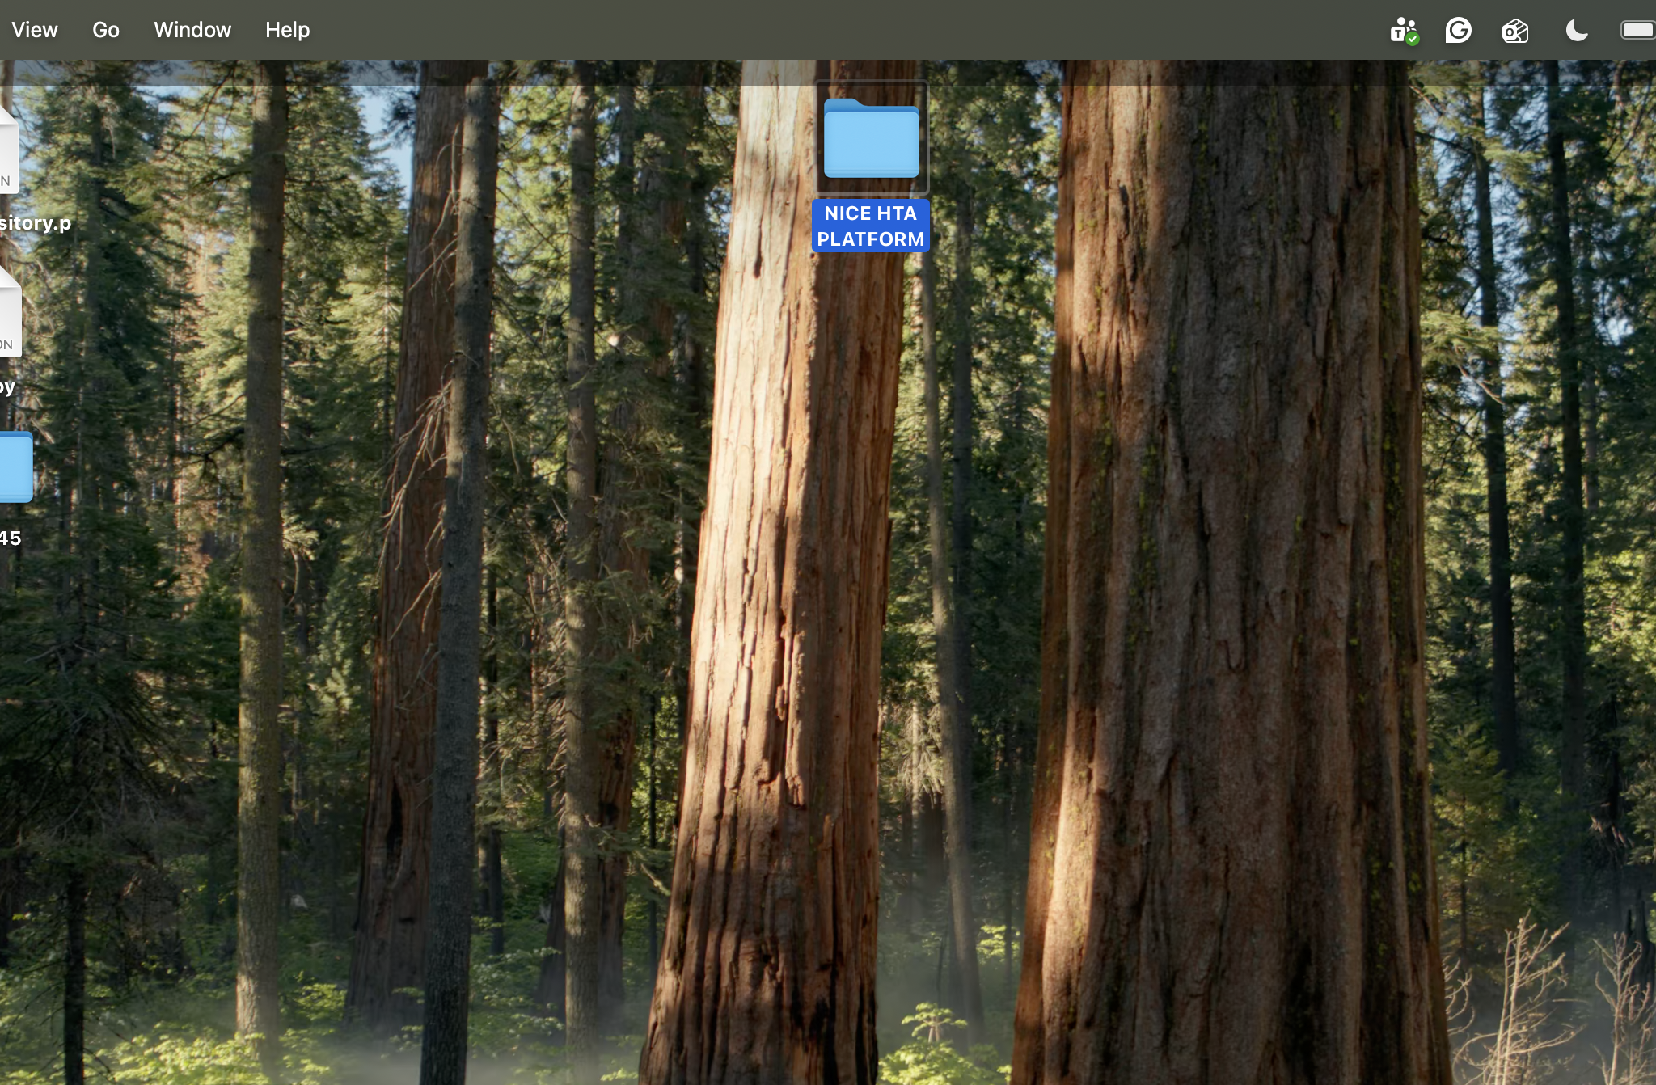
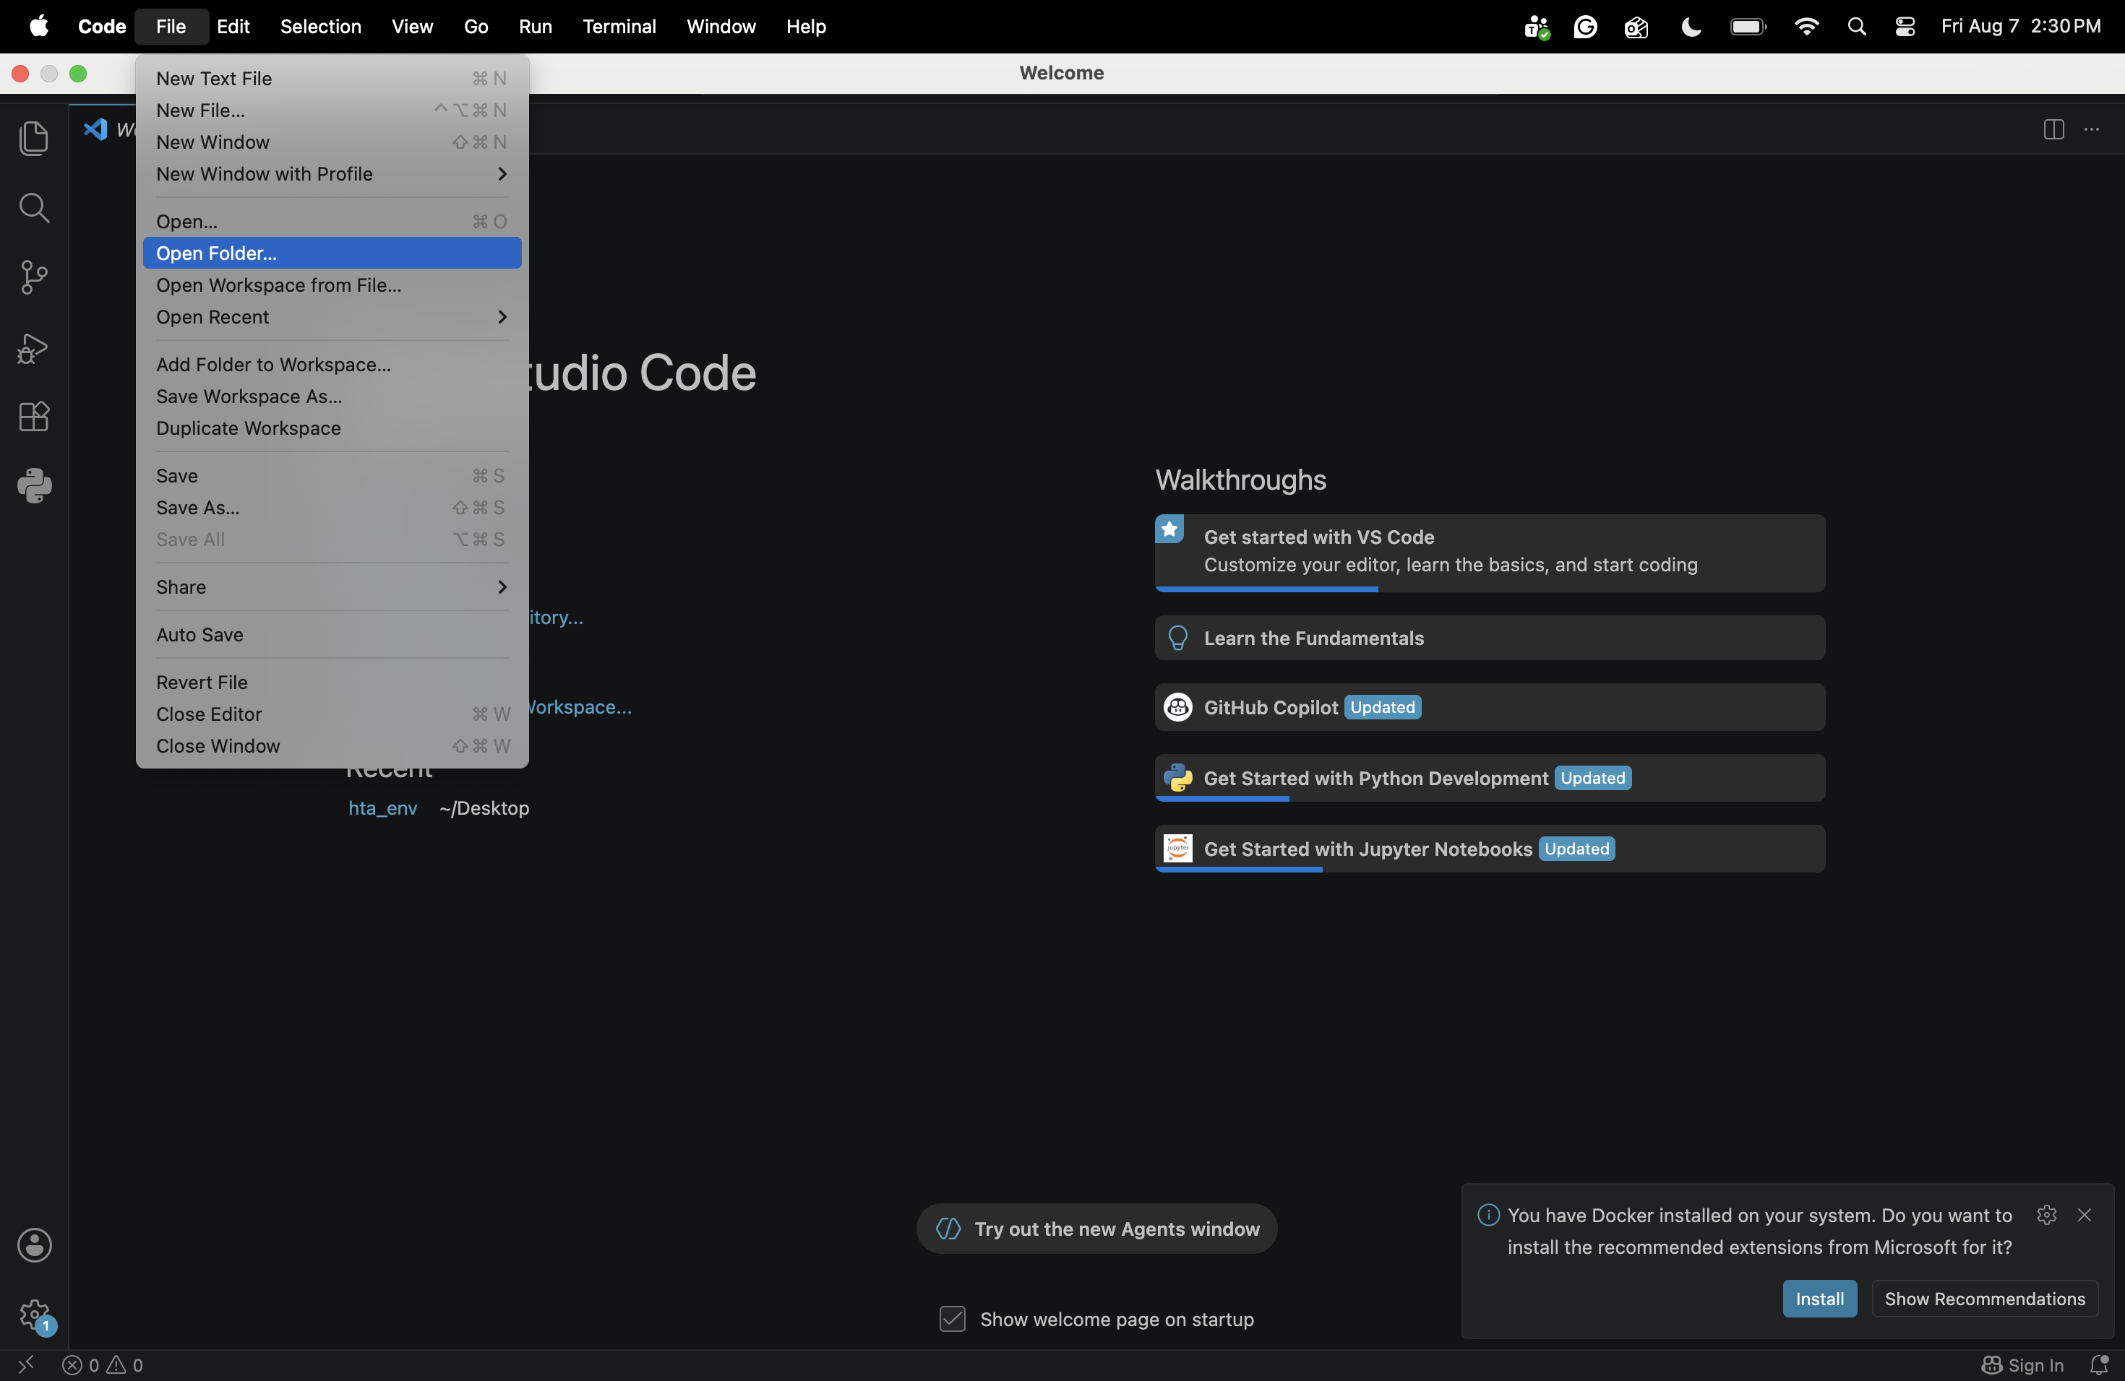

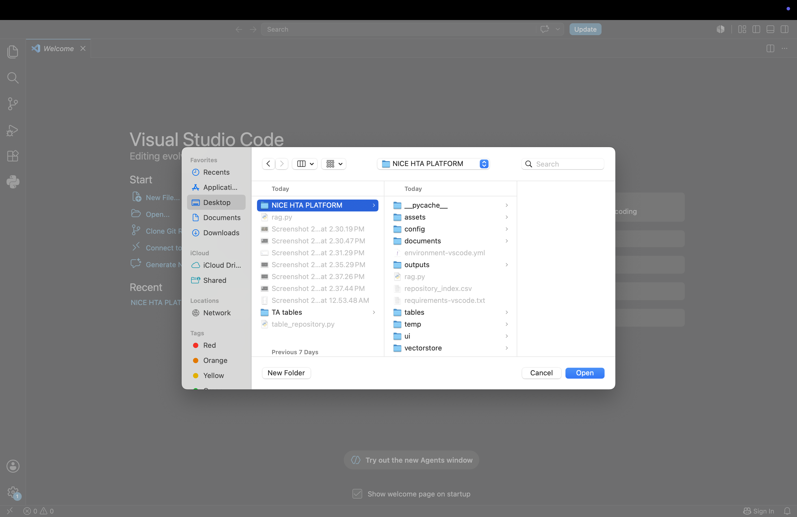

Figure 2.2 – Project Explorer / [Project Structure – Kindly note that ui folder contains rag_panel.py ; table_extraction.py; web_scraper.py ]. Rest all the files will be in project root. Only ui folder will be created manually and rest all folders will be created automatically.
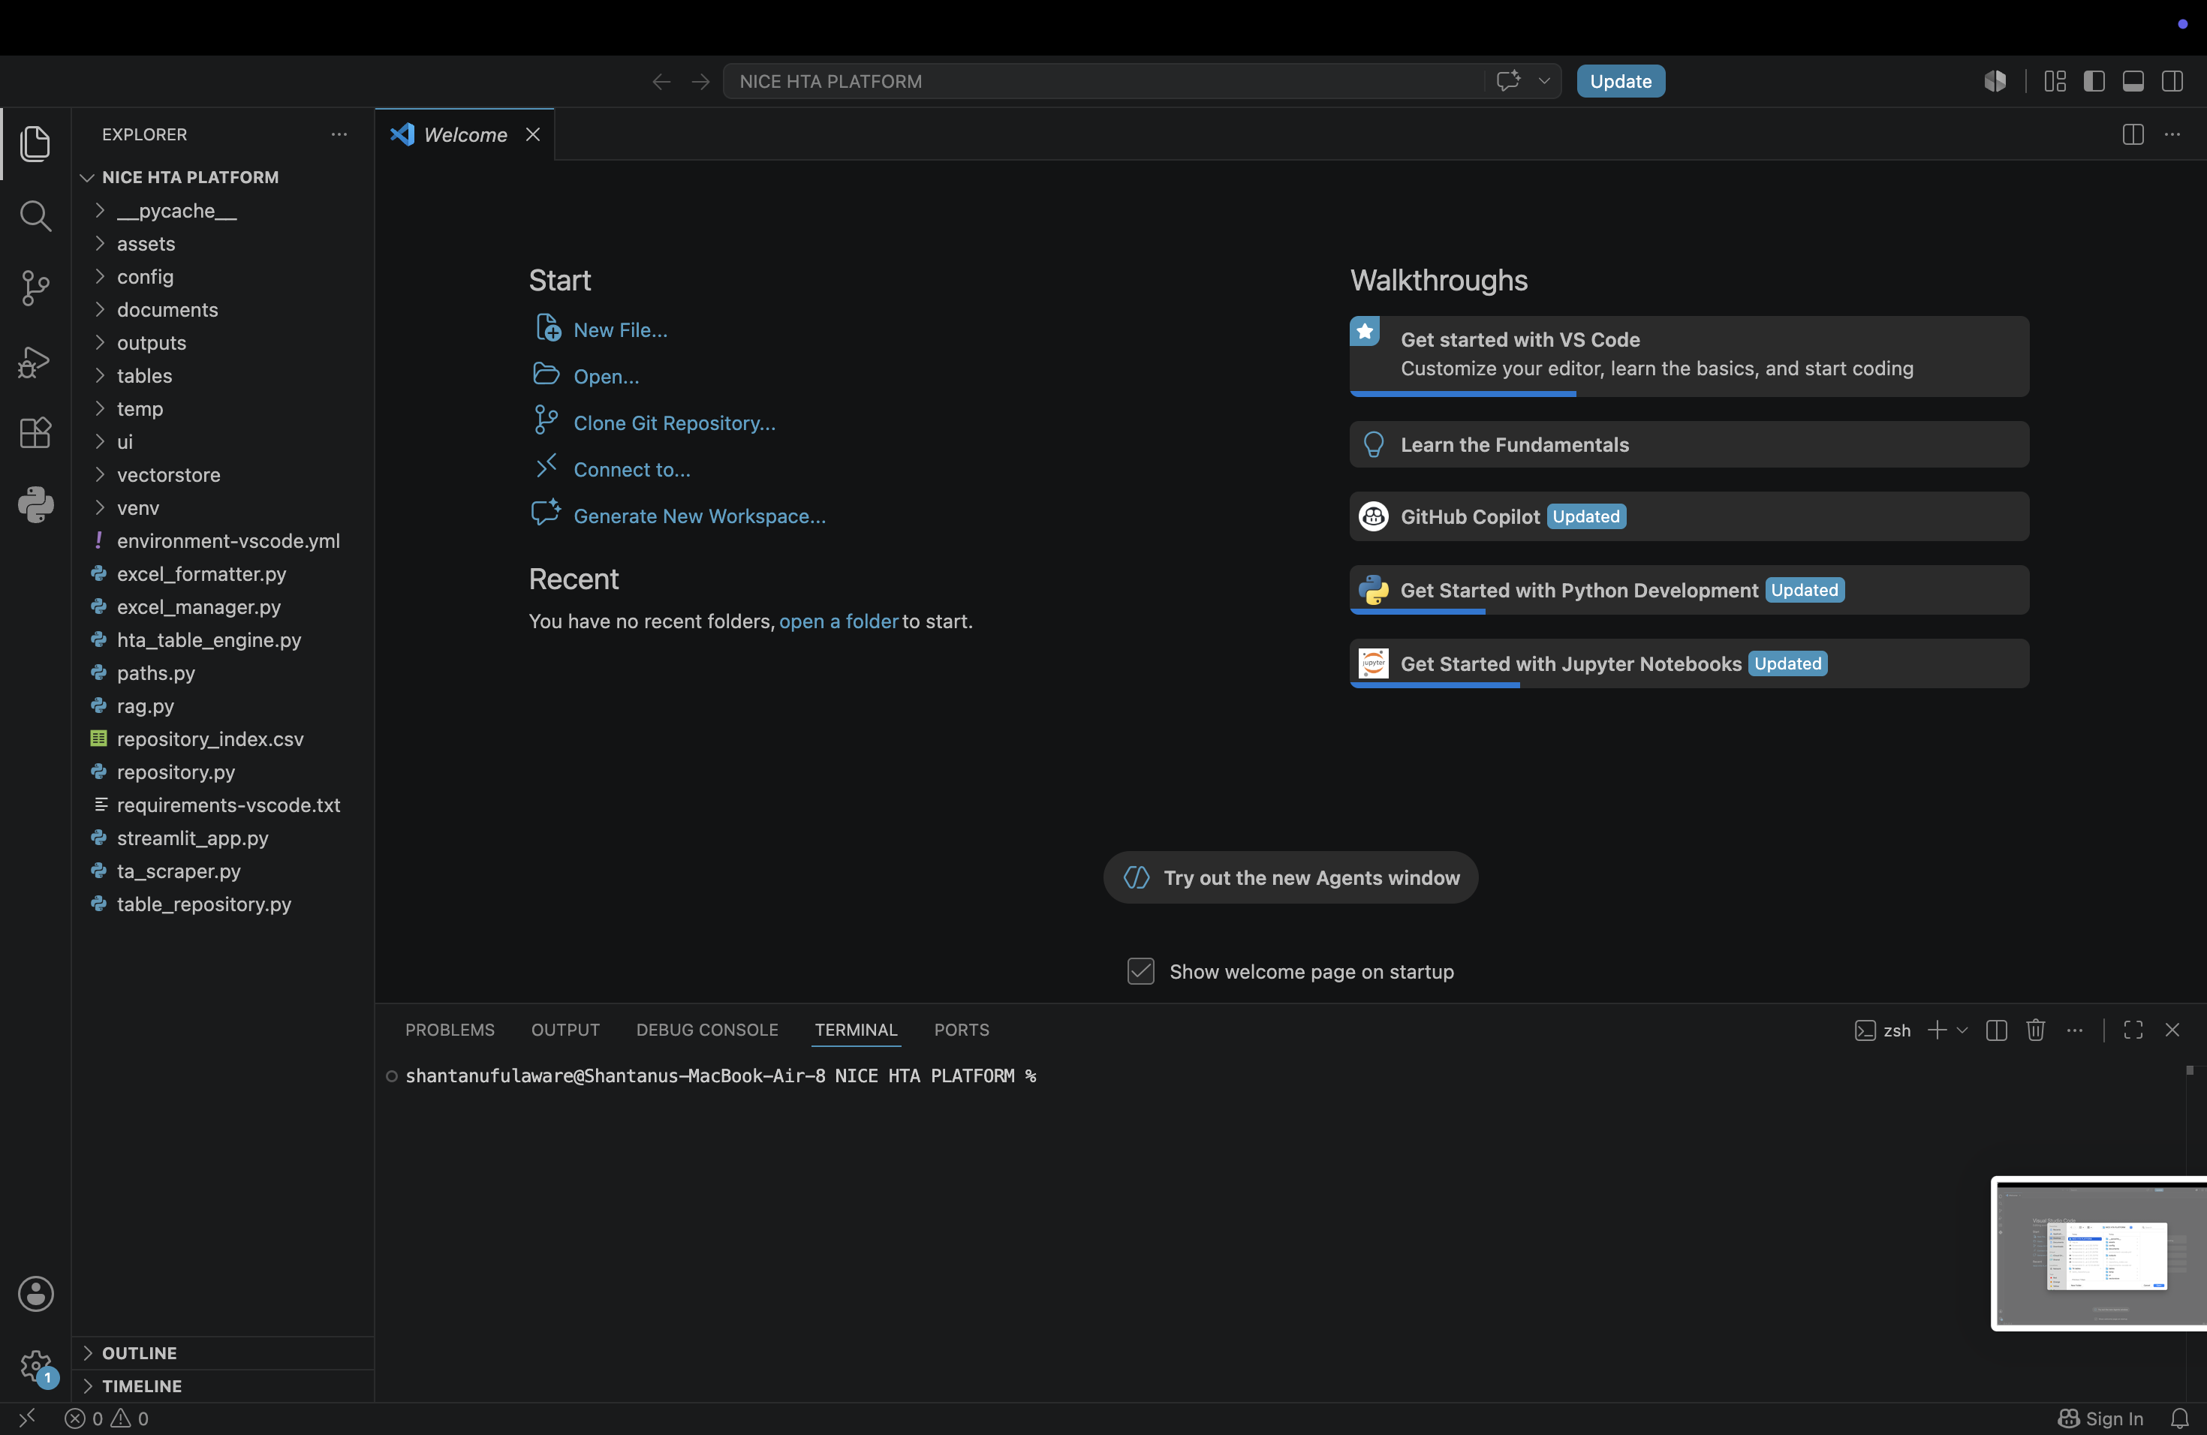

3. Activate the Python Virtual Environment
Open a new terminal in Visual Studio Code and run:
Command - source venv/bin/activate
When successful, the terminal prompt begins with (venv).
Figure 3.1 – Activated Virtual Environment
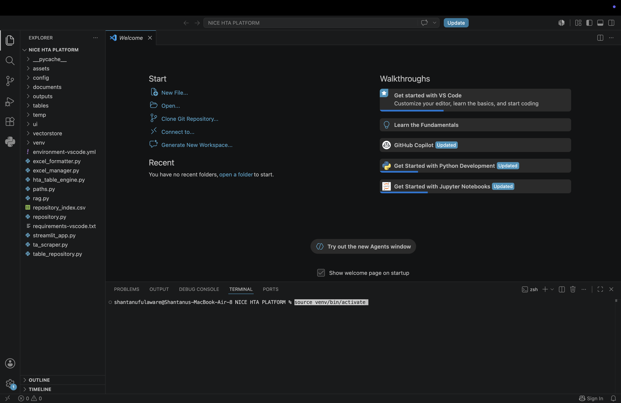

4. Install Project Dependencies
Run the following command once:
Command - pip install -r requirements-vscode.txt
If all packages are already installed, pip will display 'Requirement already satisfied' for each package.
Figure 4.1 – Dependency Installation

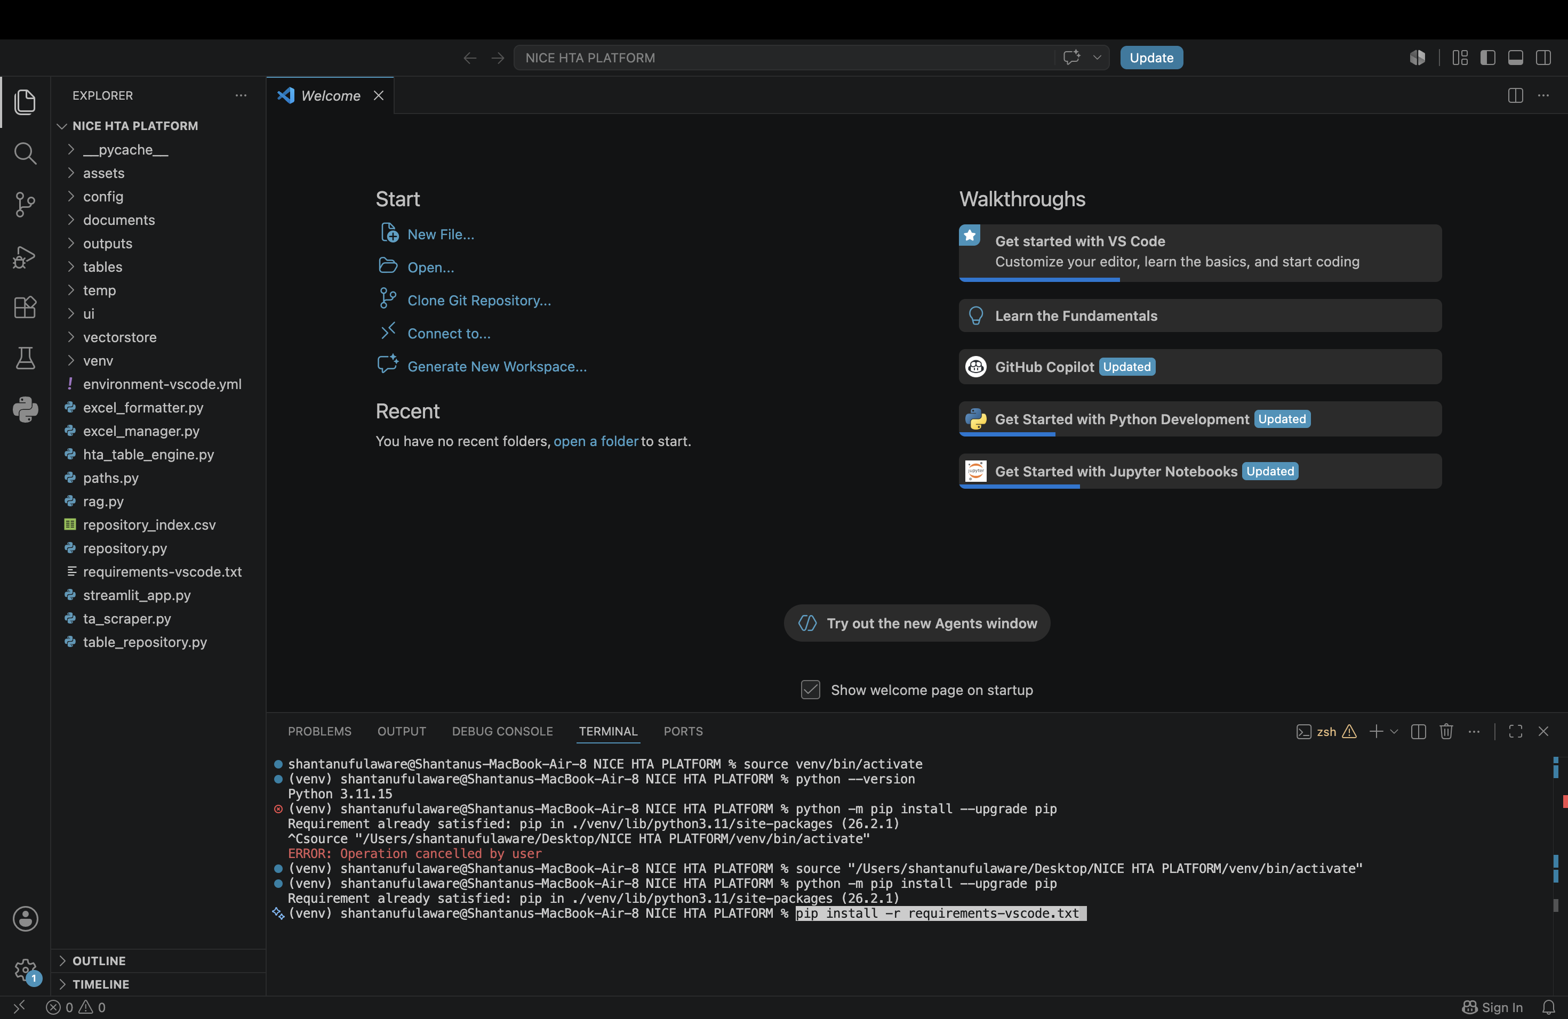
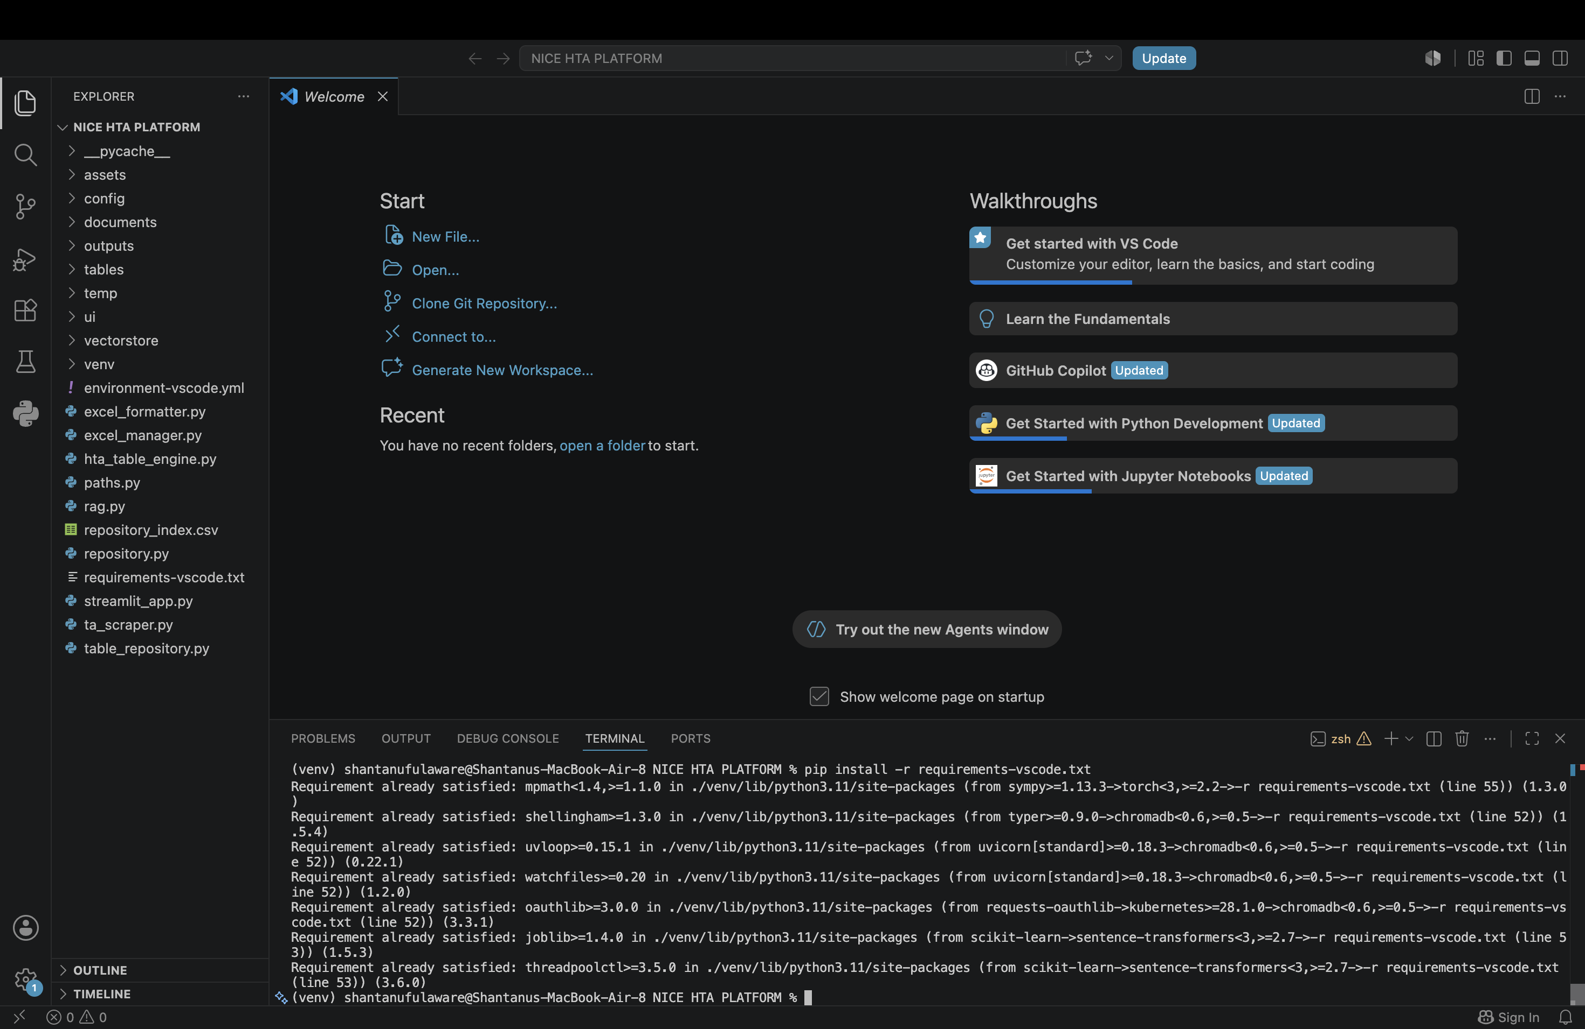

5. Verify Supporting Software

Ghostscript
Run:
Command - gs --version
A version number confirms successful installation.
Figure 5.1 – Ghostscript Verification

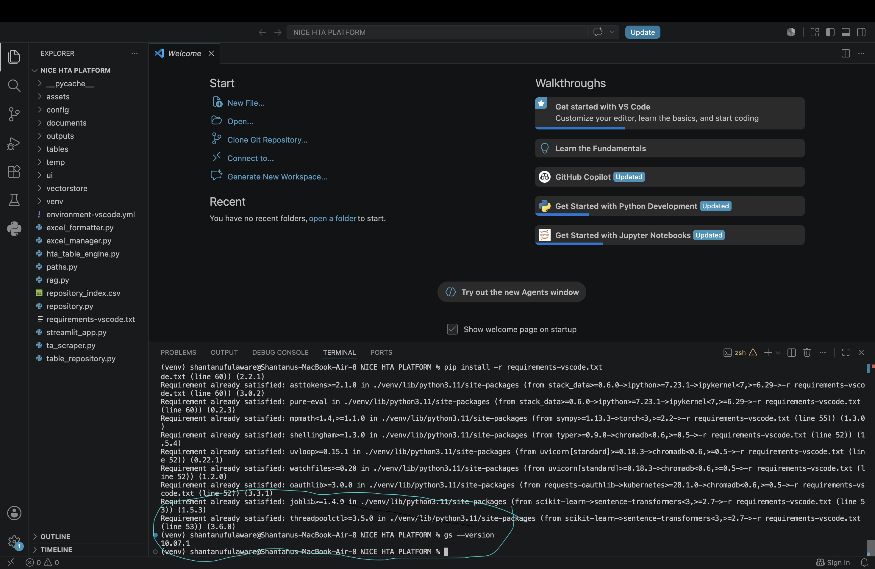

Ollama
Run:
Command - ollama list
Confirm that the required model is listed.
Figure 5.2 – Ollama Verification
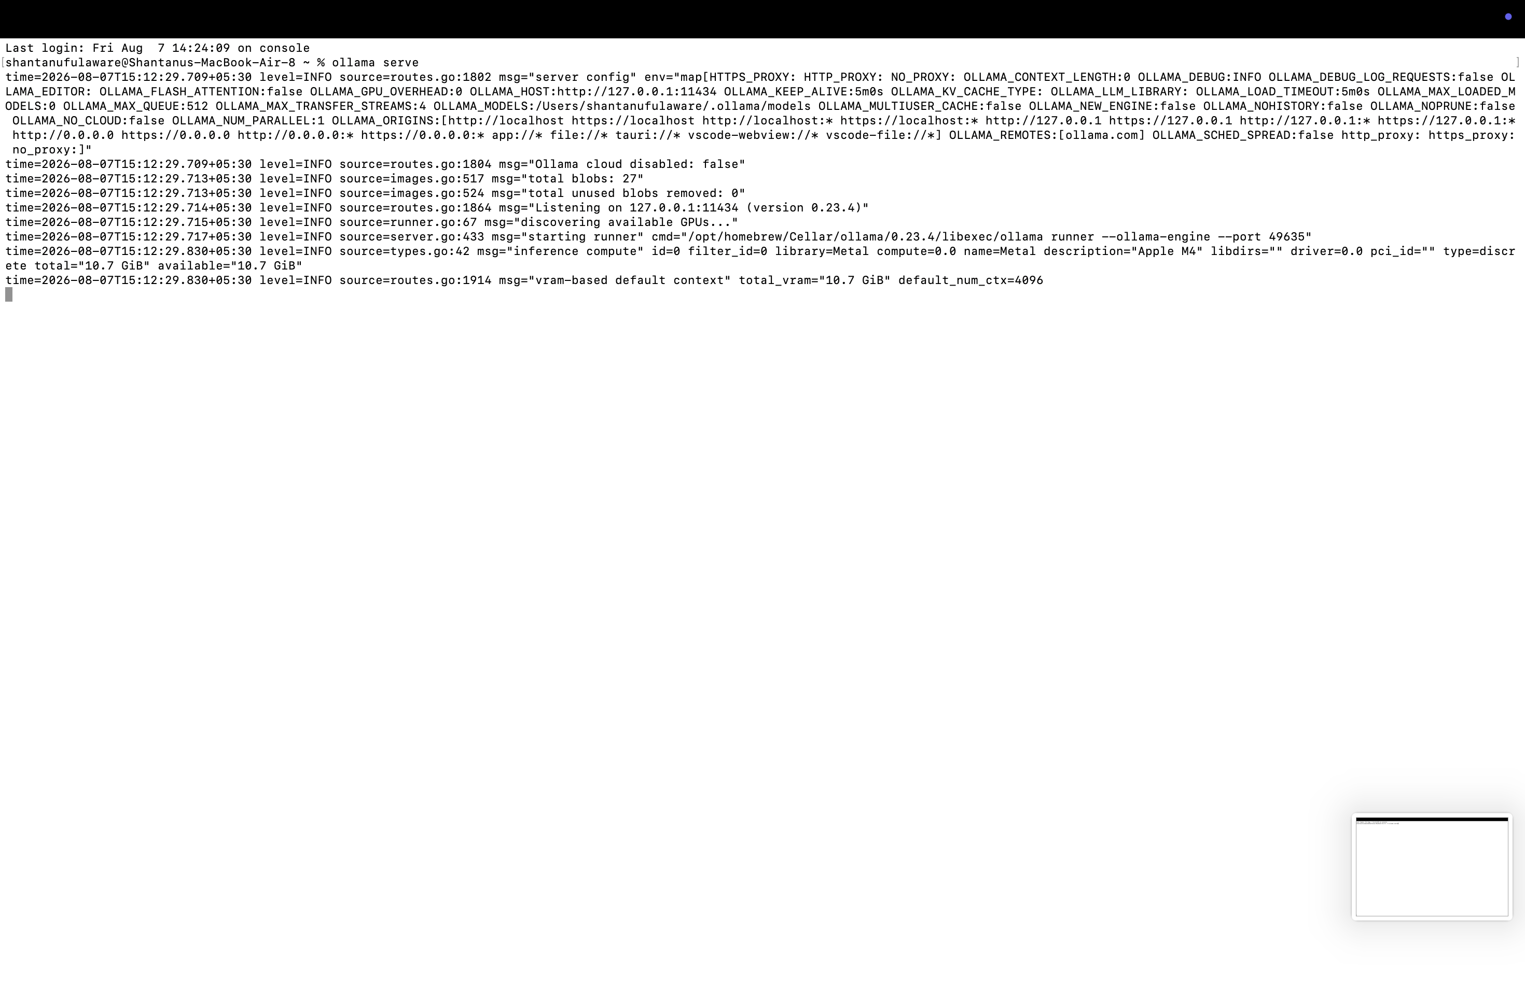

6. Start the HTA Platform
Run:
Command - python -m streamlit run streamlit_app.py
Open the Local URL displayed in the terminal (typically http://localhost:8501).
Figure 6.1 – Launching Streamlit

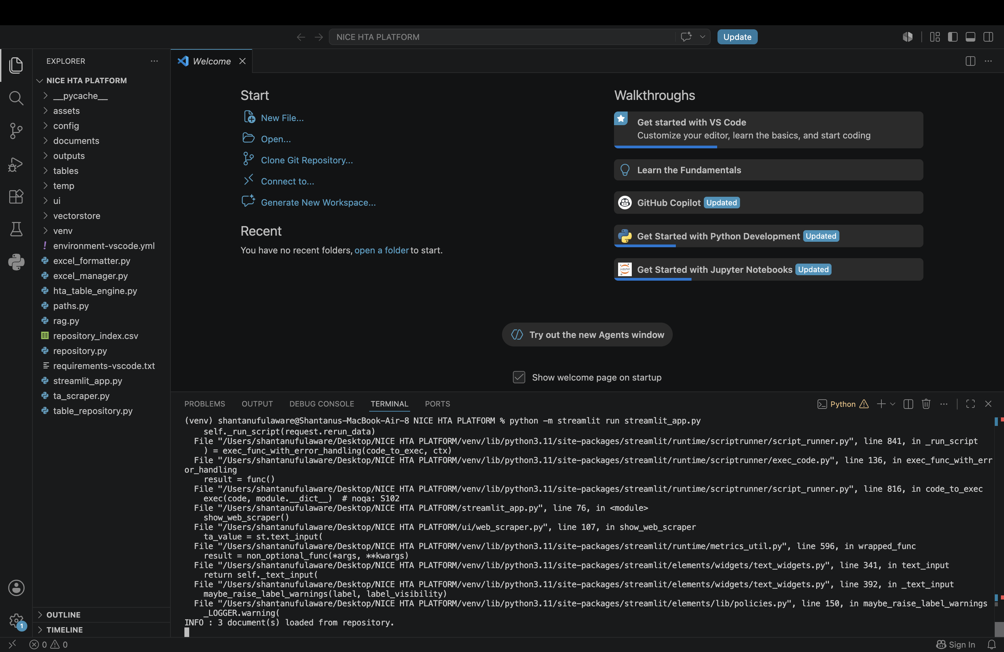

Figure 6.2 – HTA Platform Home Screen
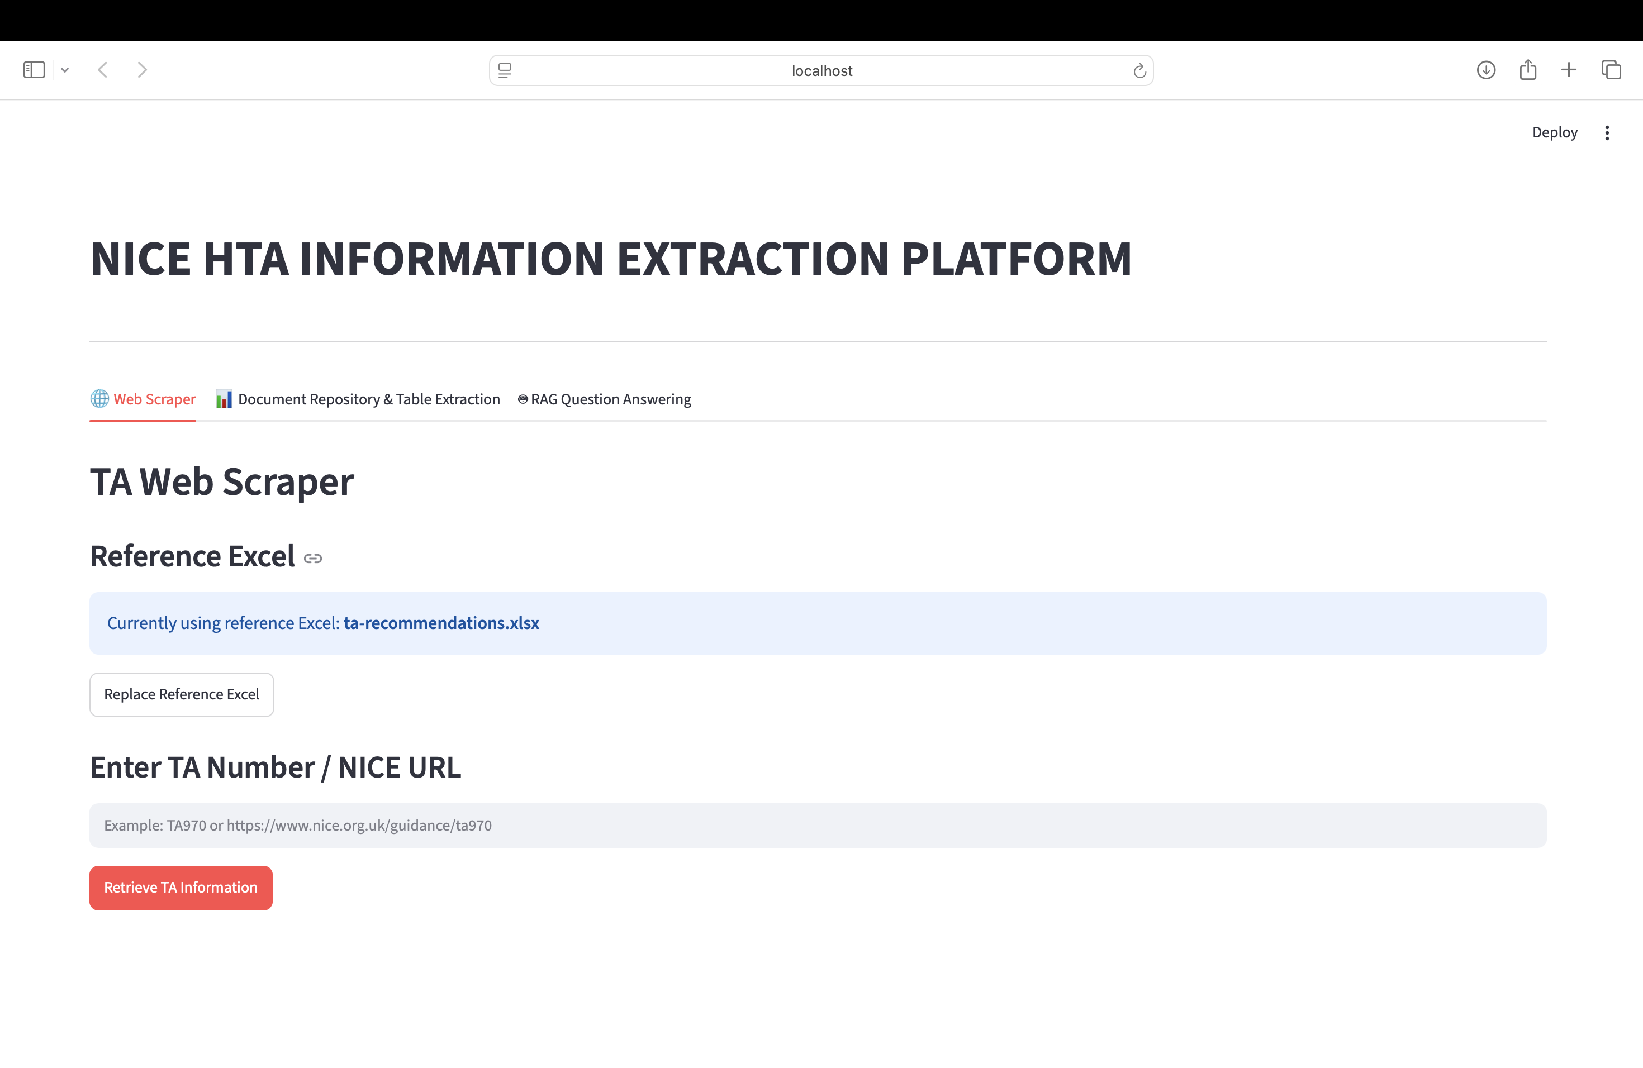

7. TA Web Scraper
The TA Web Scraper retrieves information from NICE Technology Appraisal (TA) guidance pages using a TA number or NICE guidance URL. Users can upload or replace a reference Excel file, enter a TA identifier, retrieve information, review the results, and download them as CSV or Excel.
Steps:
1. Open the 'TA Web Scraper' tab.
2. Upload or replace the reference Excel if required. (REFERENCE EXCEL IS ATTACHED IN THE MAIL – REFER ta-recommendations excel )
3. Enter a TA number (e.g. TA970) or a NICE guidance URL.
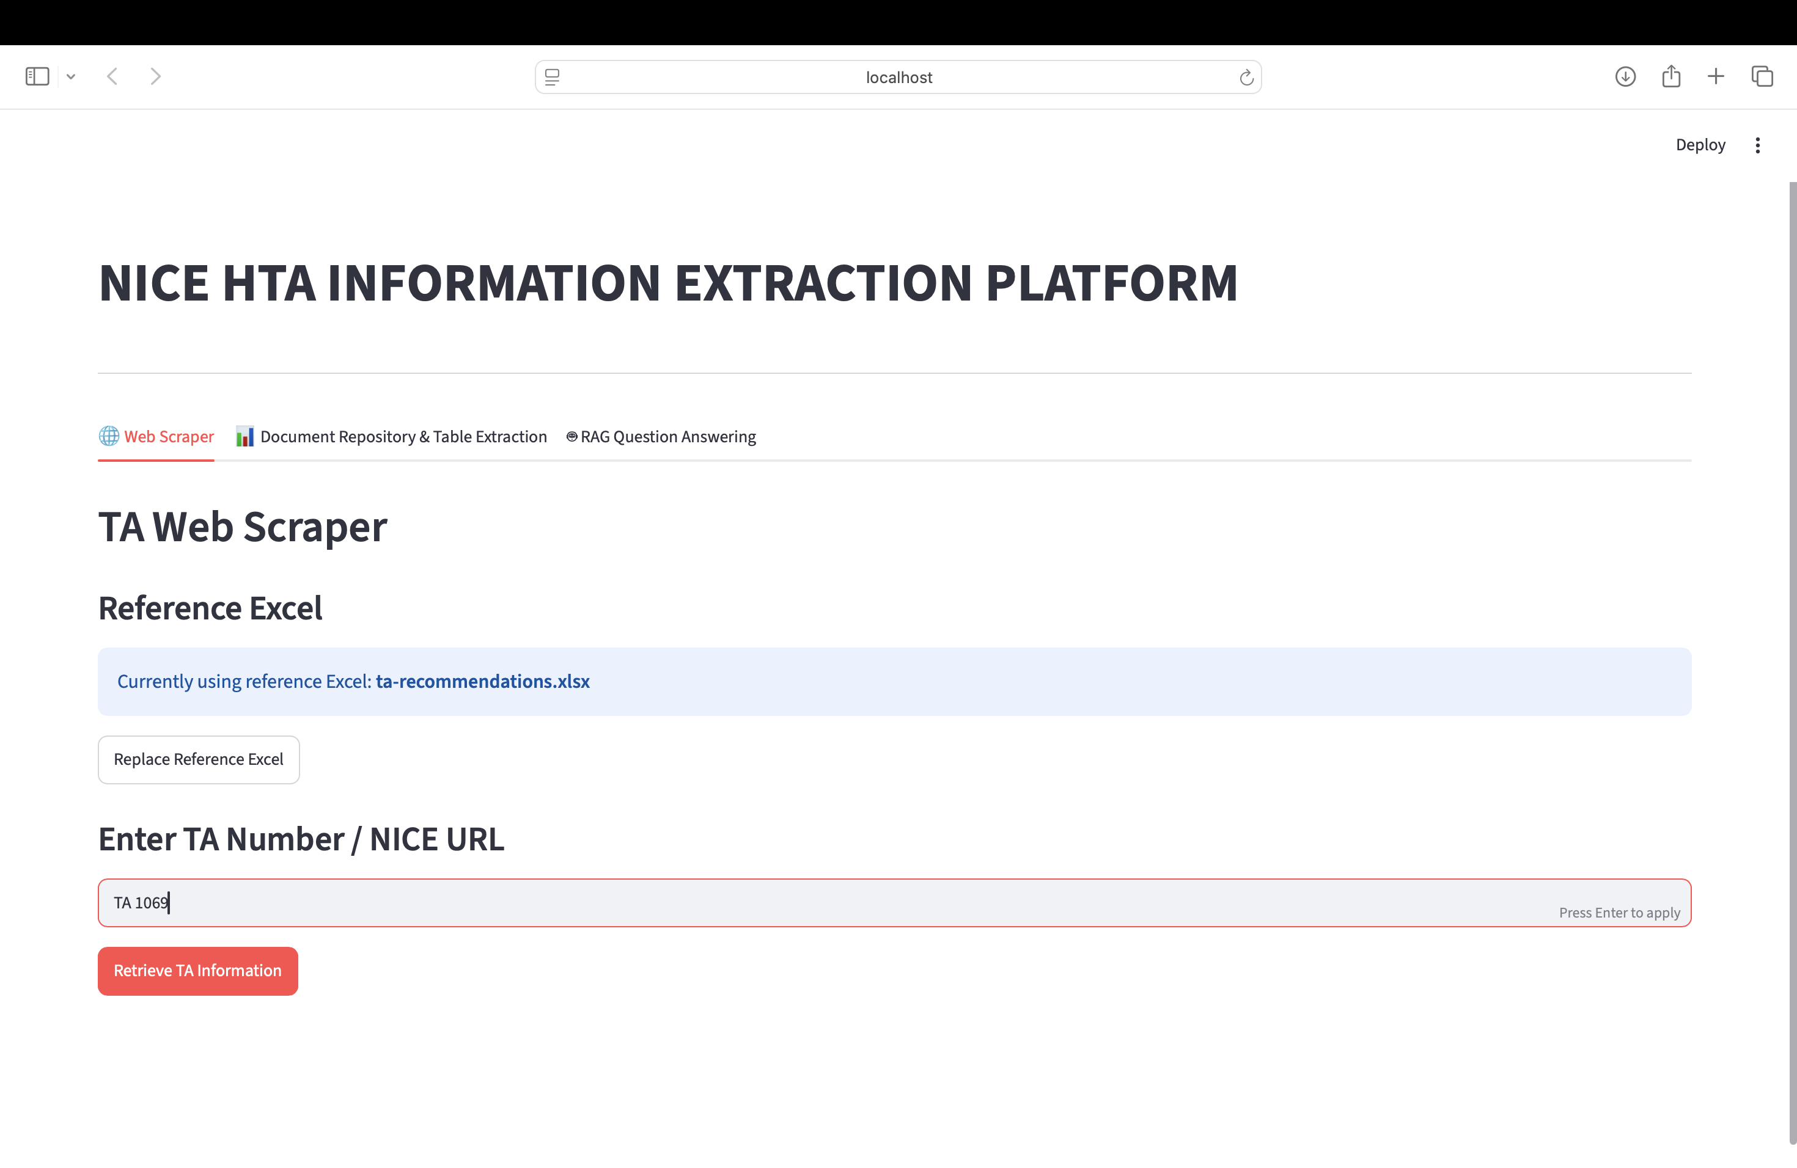
4. Select 'Retrieve TA Information'.

5. Review the extracted information.
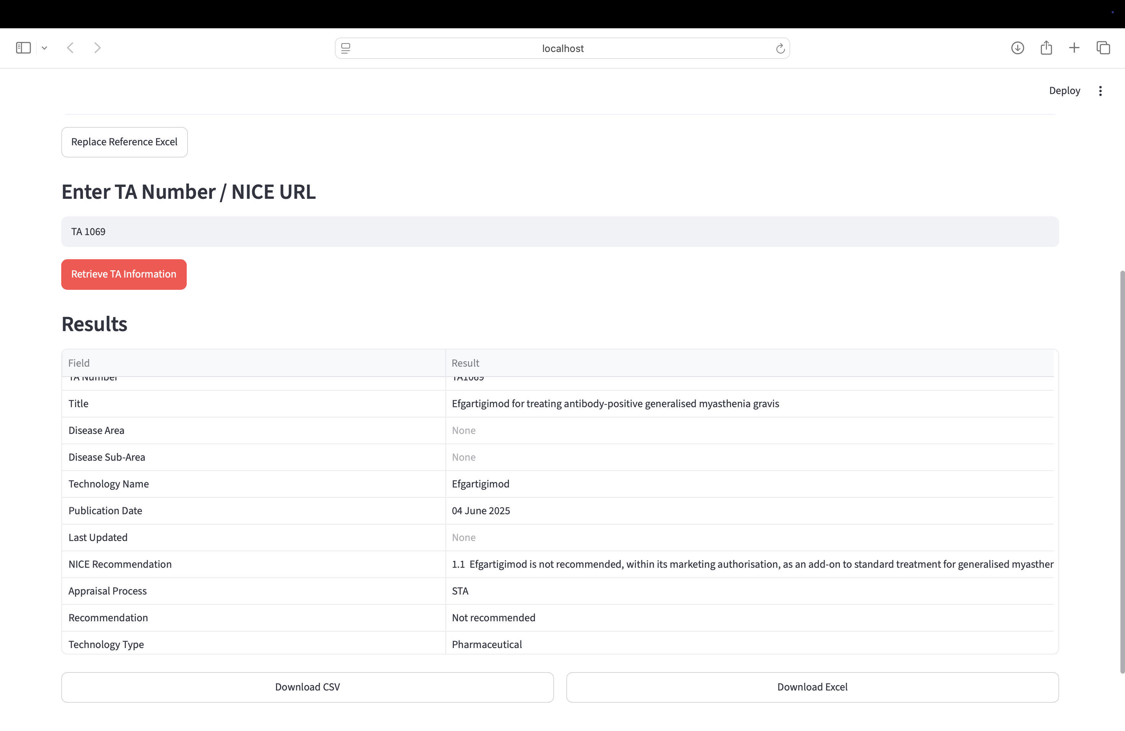
6. Download the results as CSV or Excel.
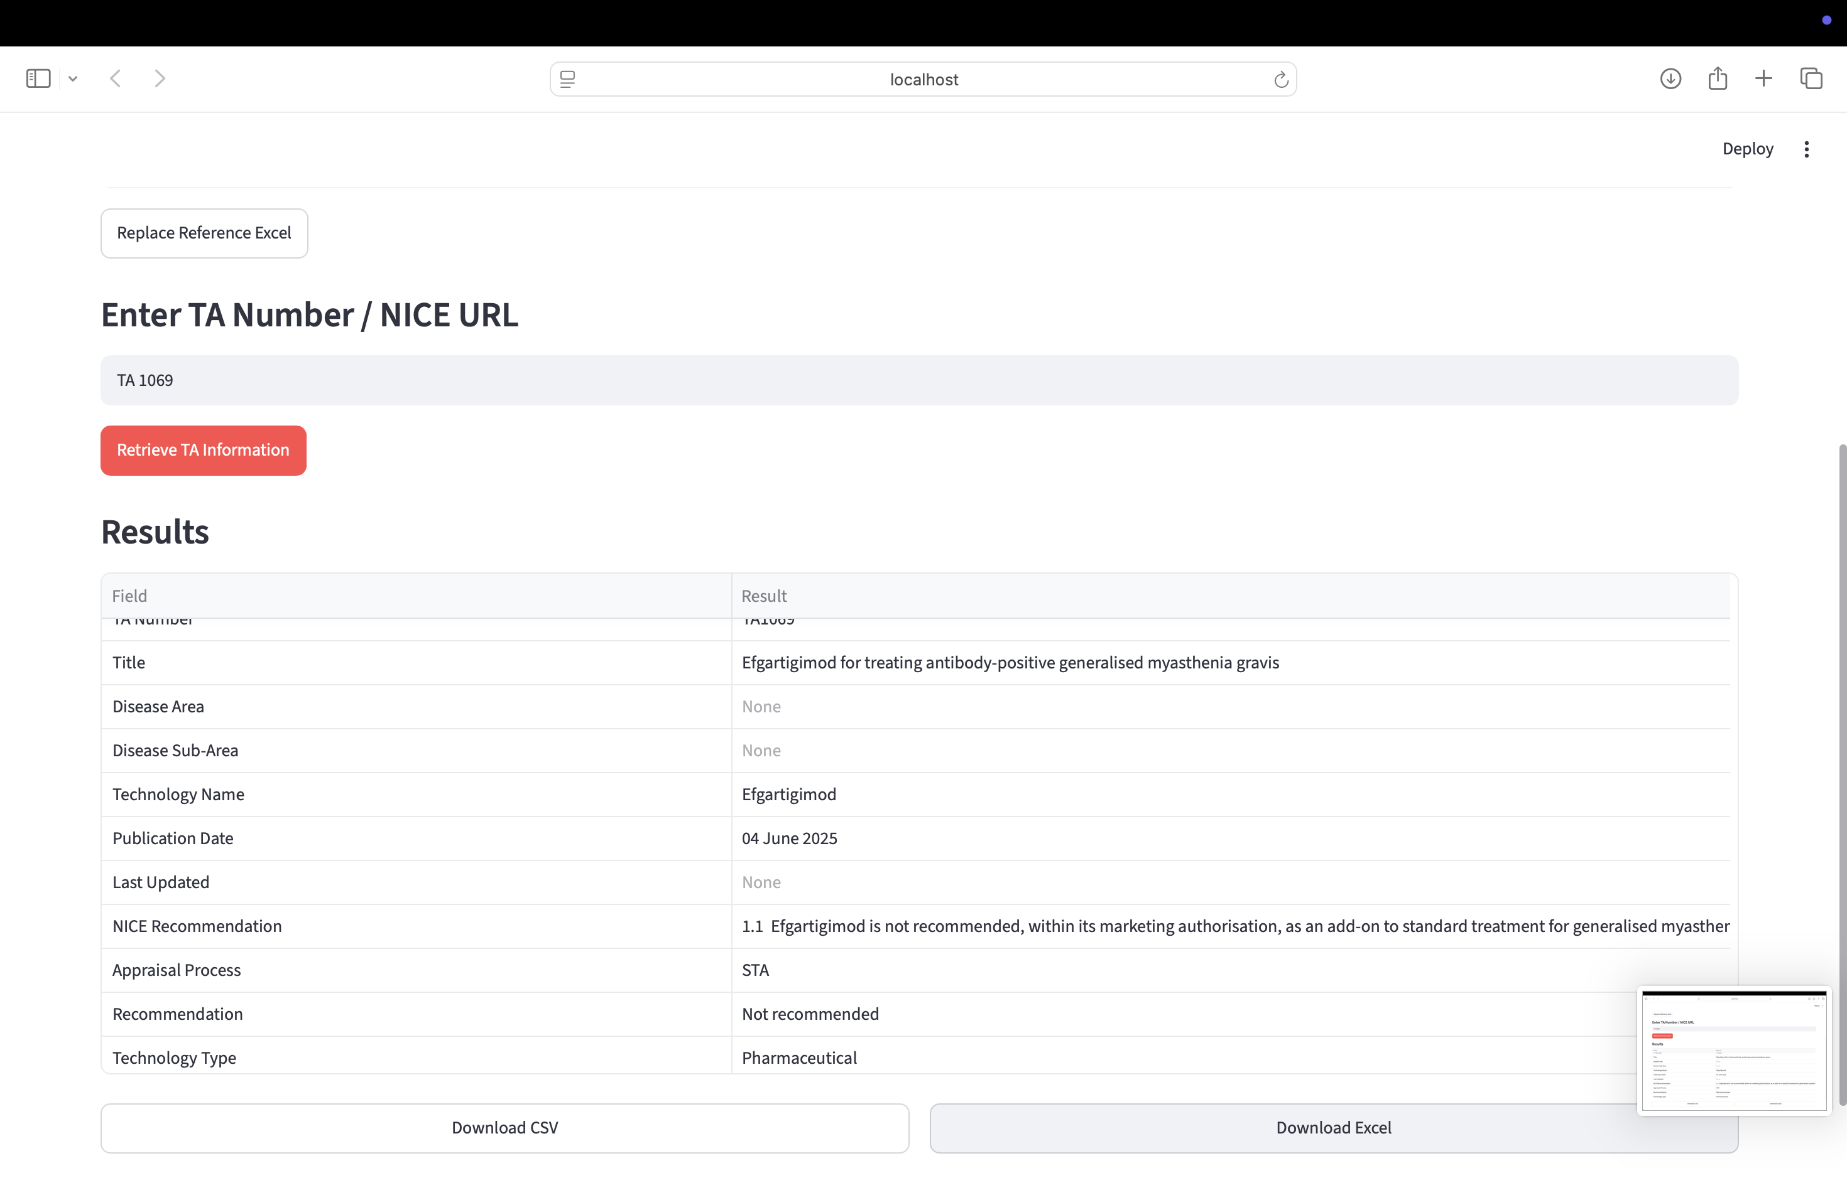

8. Document Repository and Table Extraction
This module discovers NICE documents, downloads selected files, maintains a local repository, previews PDFs, and extracts tables from downloaded documents.
Workflow:
1. Discover documents.
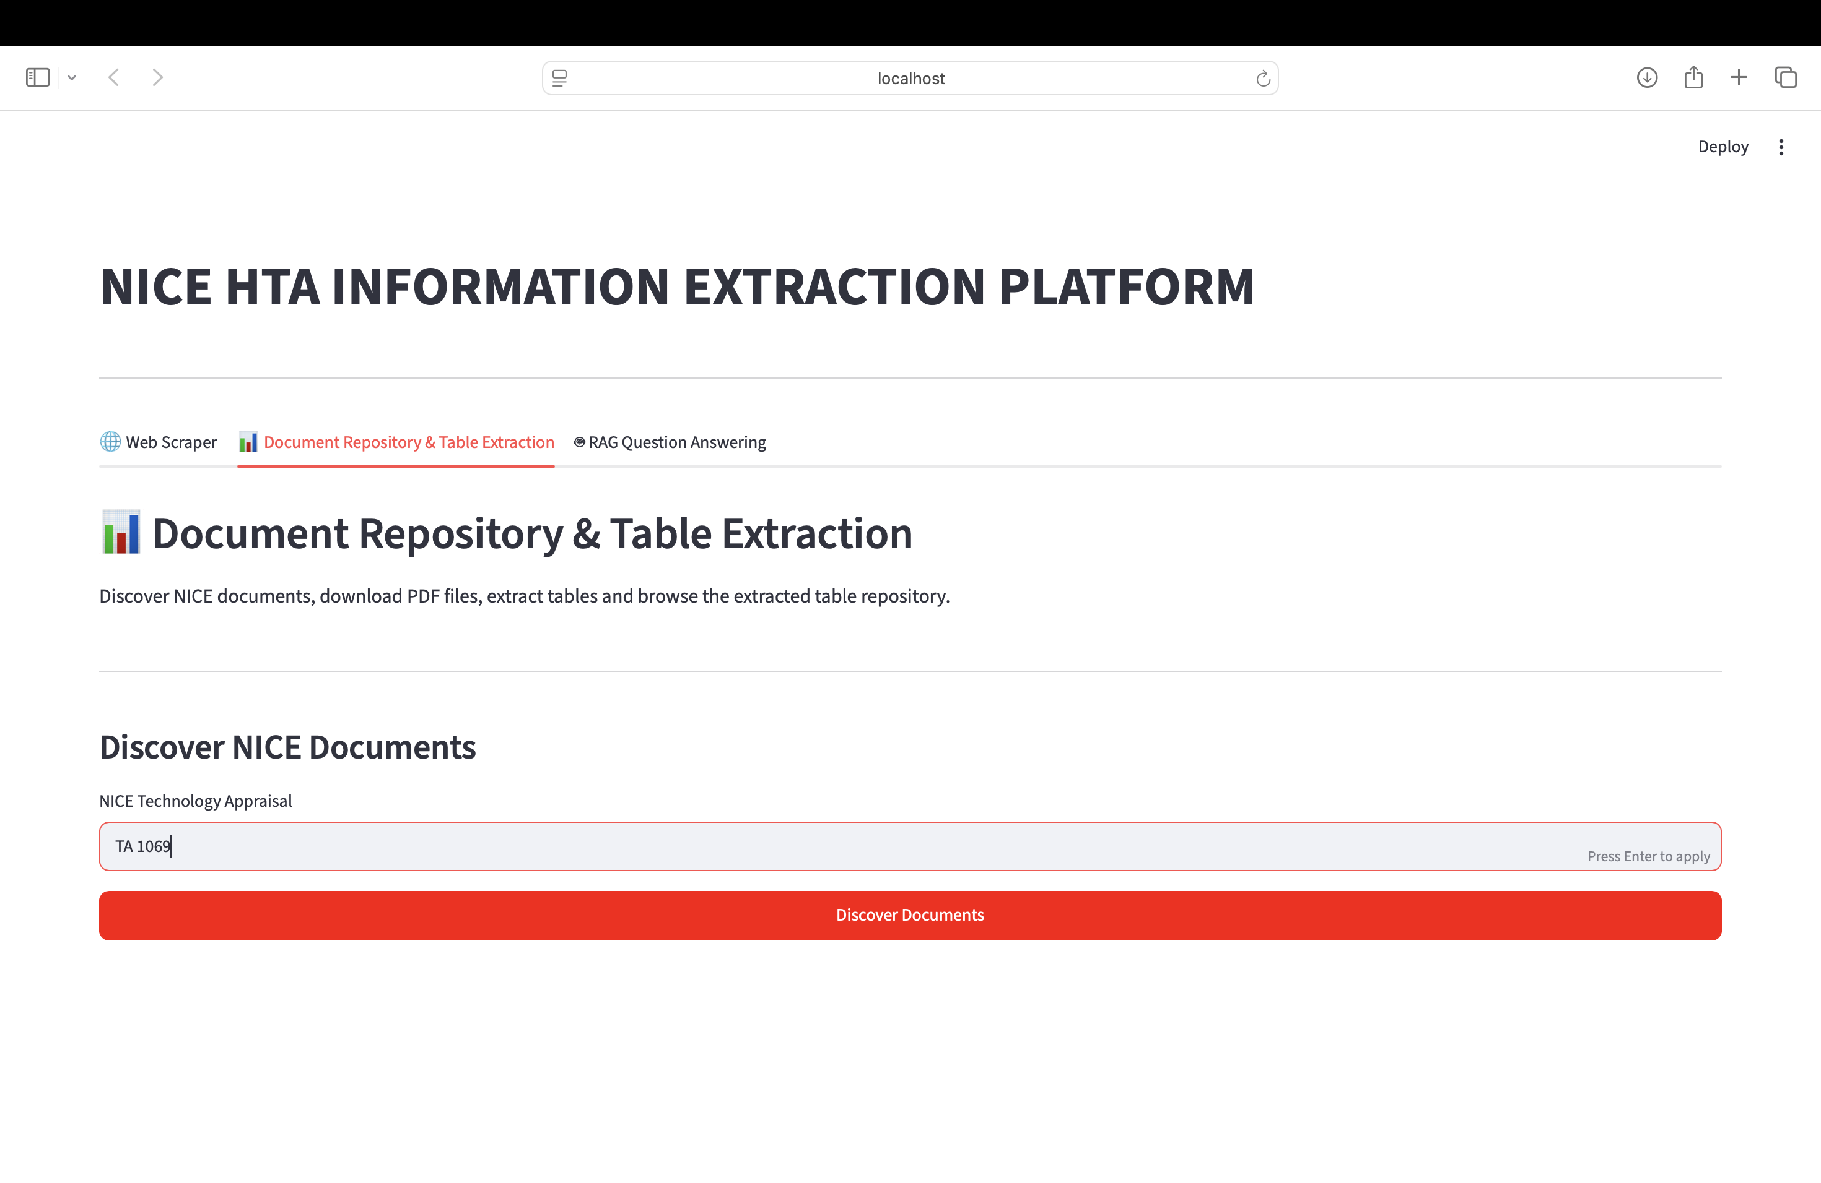
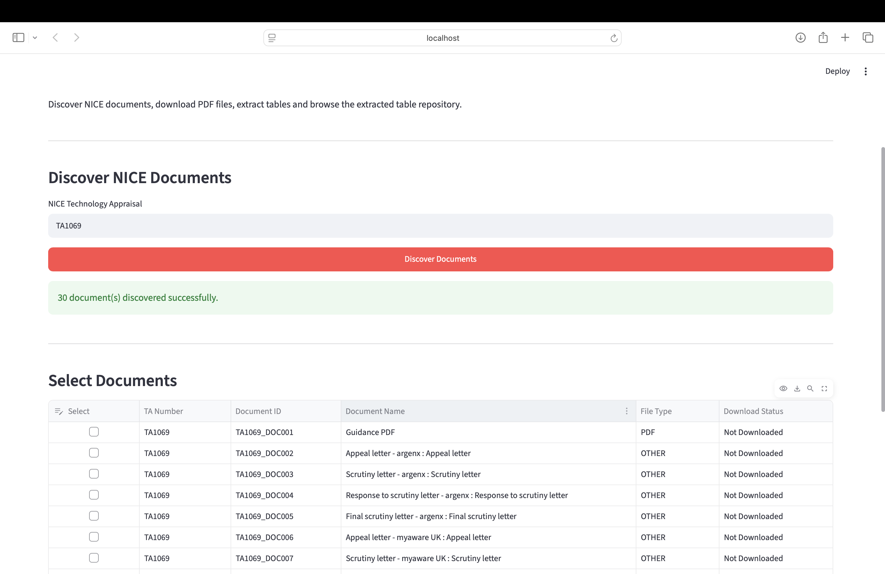

2. Select and download documents.

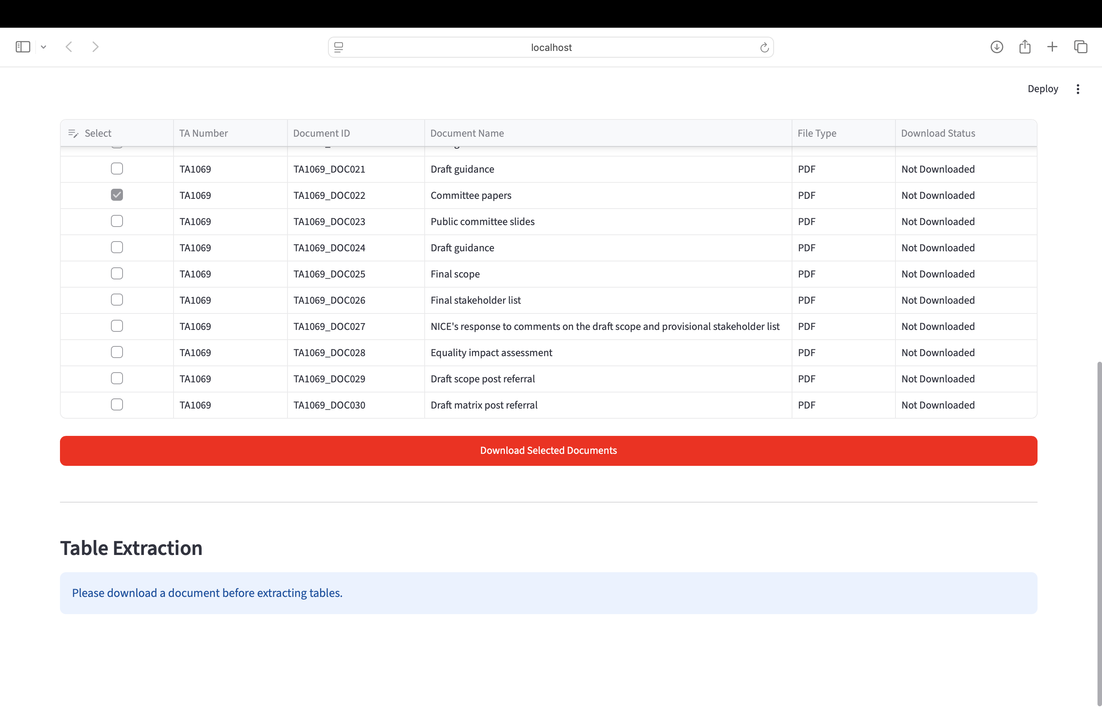
3. Preview or download PDFs.

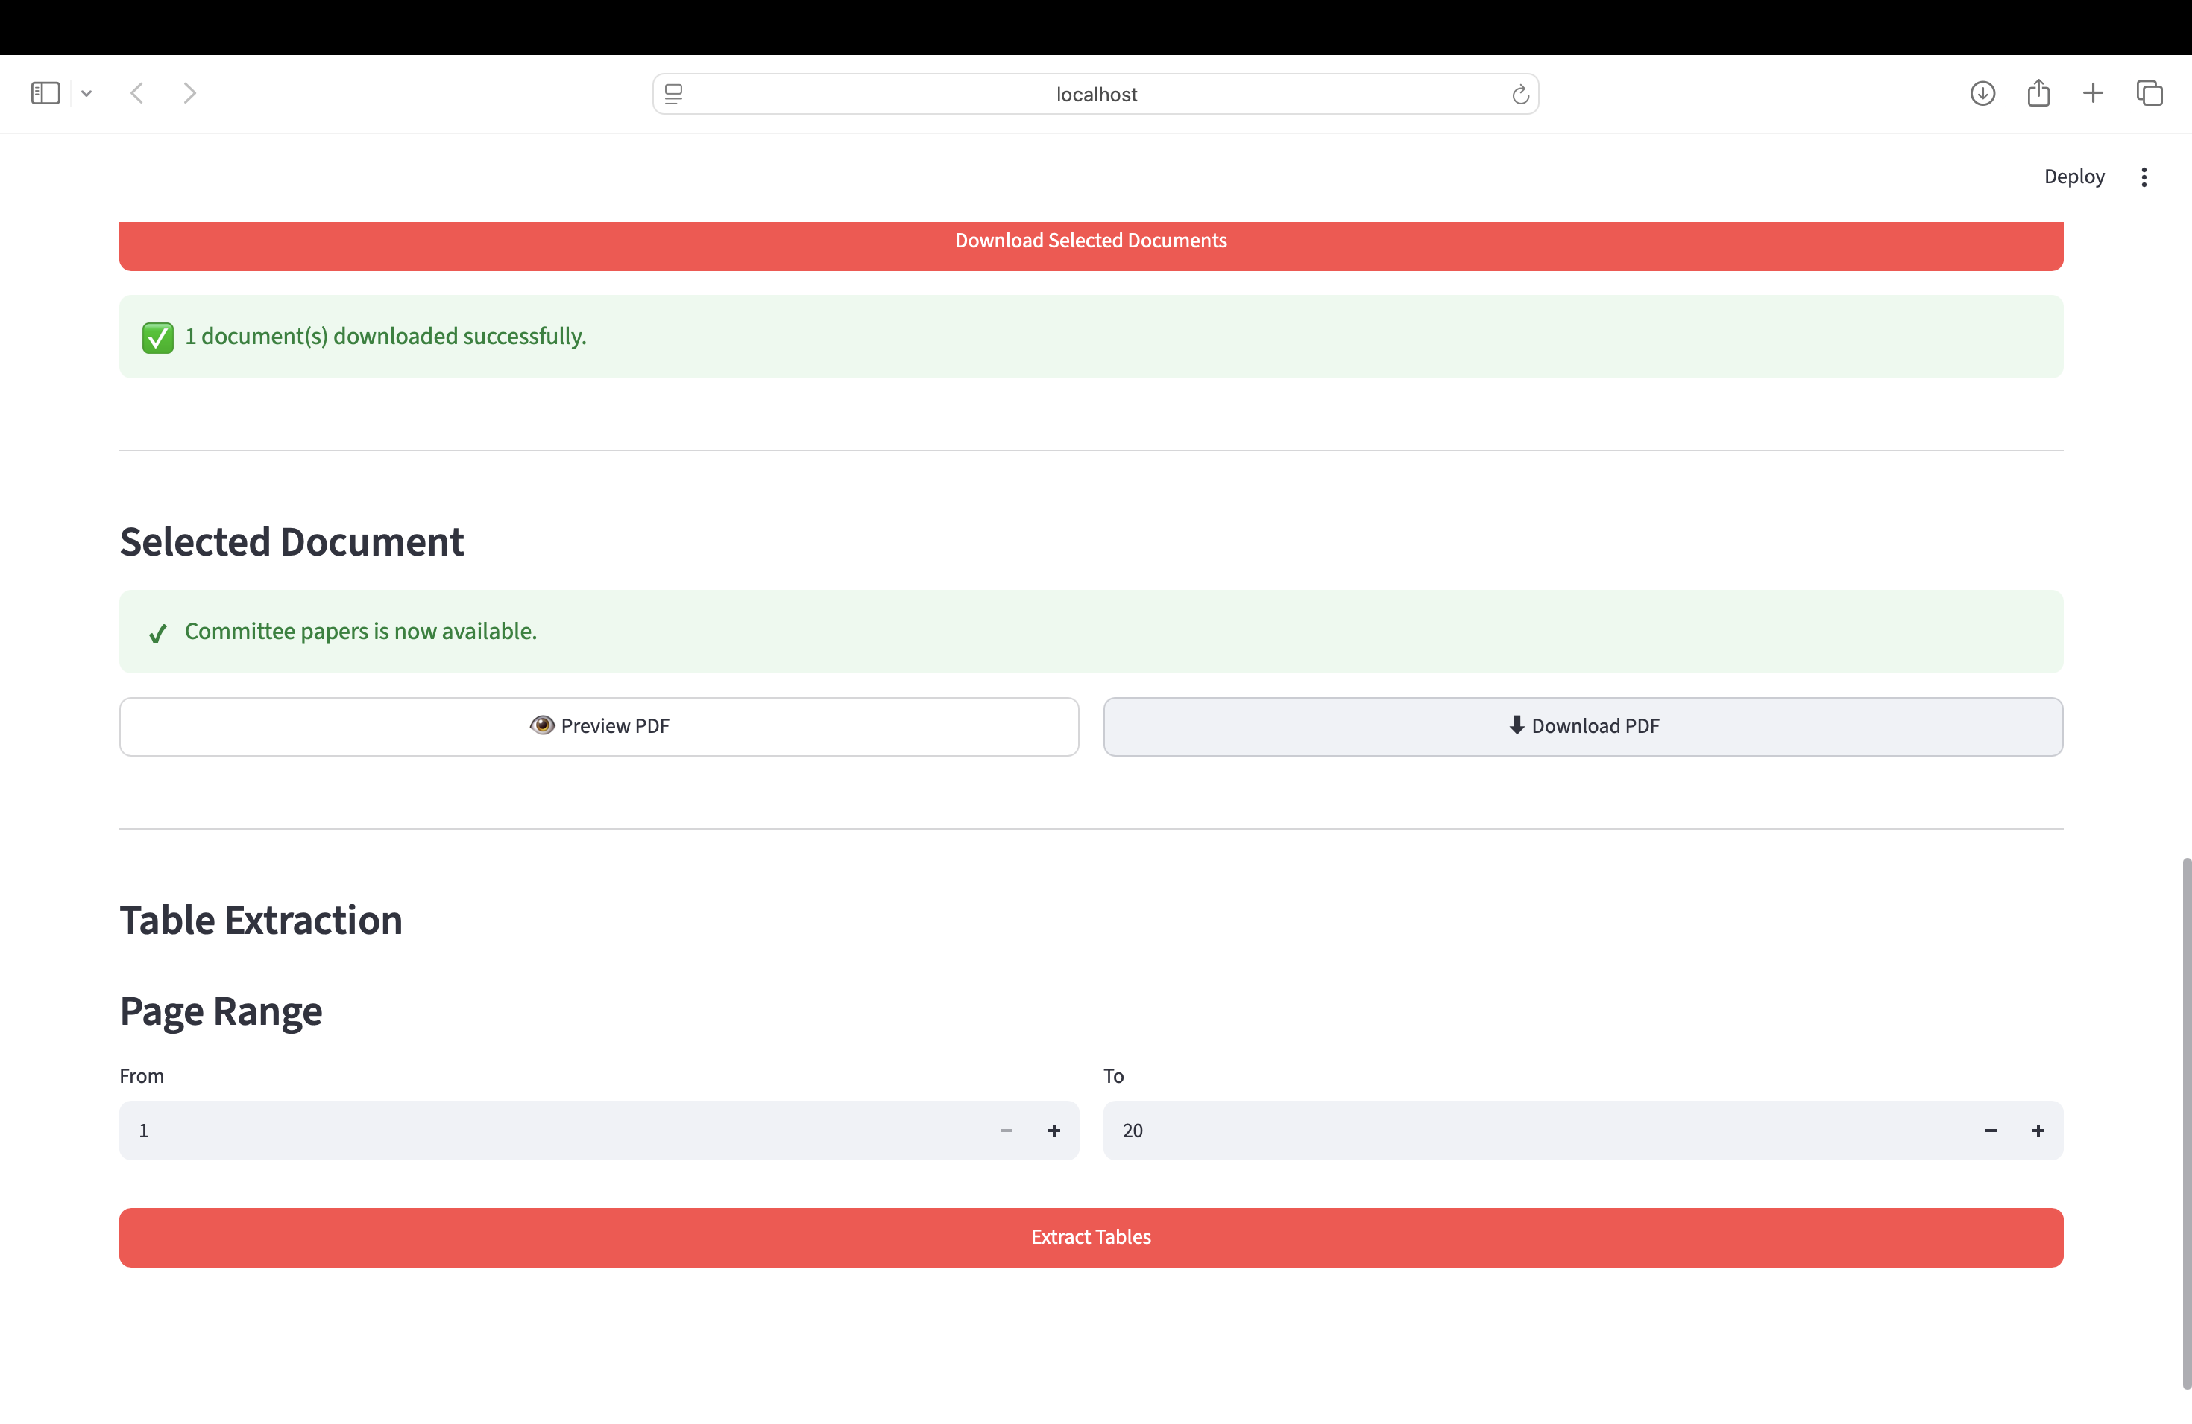
4. Specify a page range.
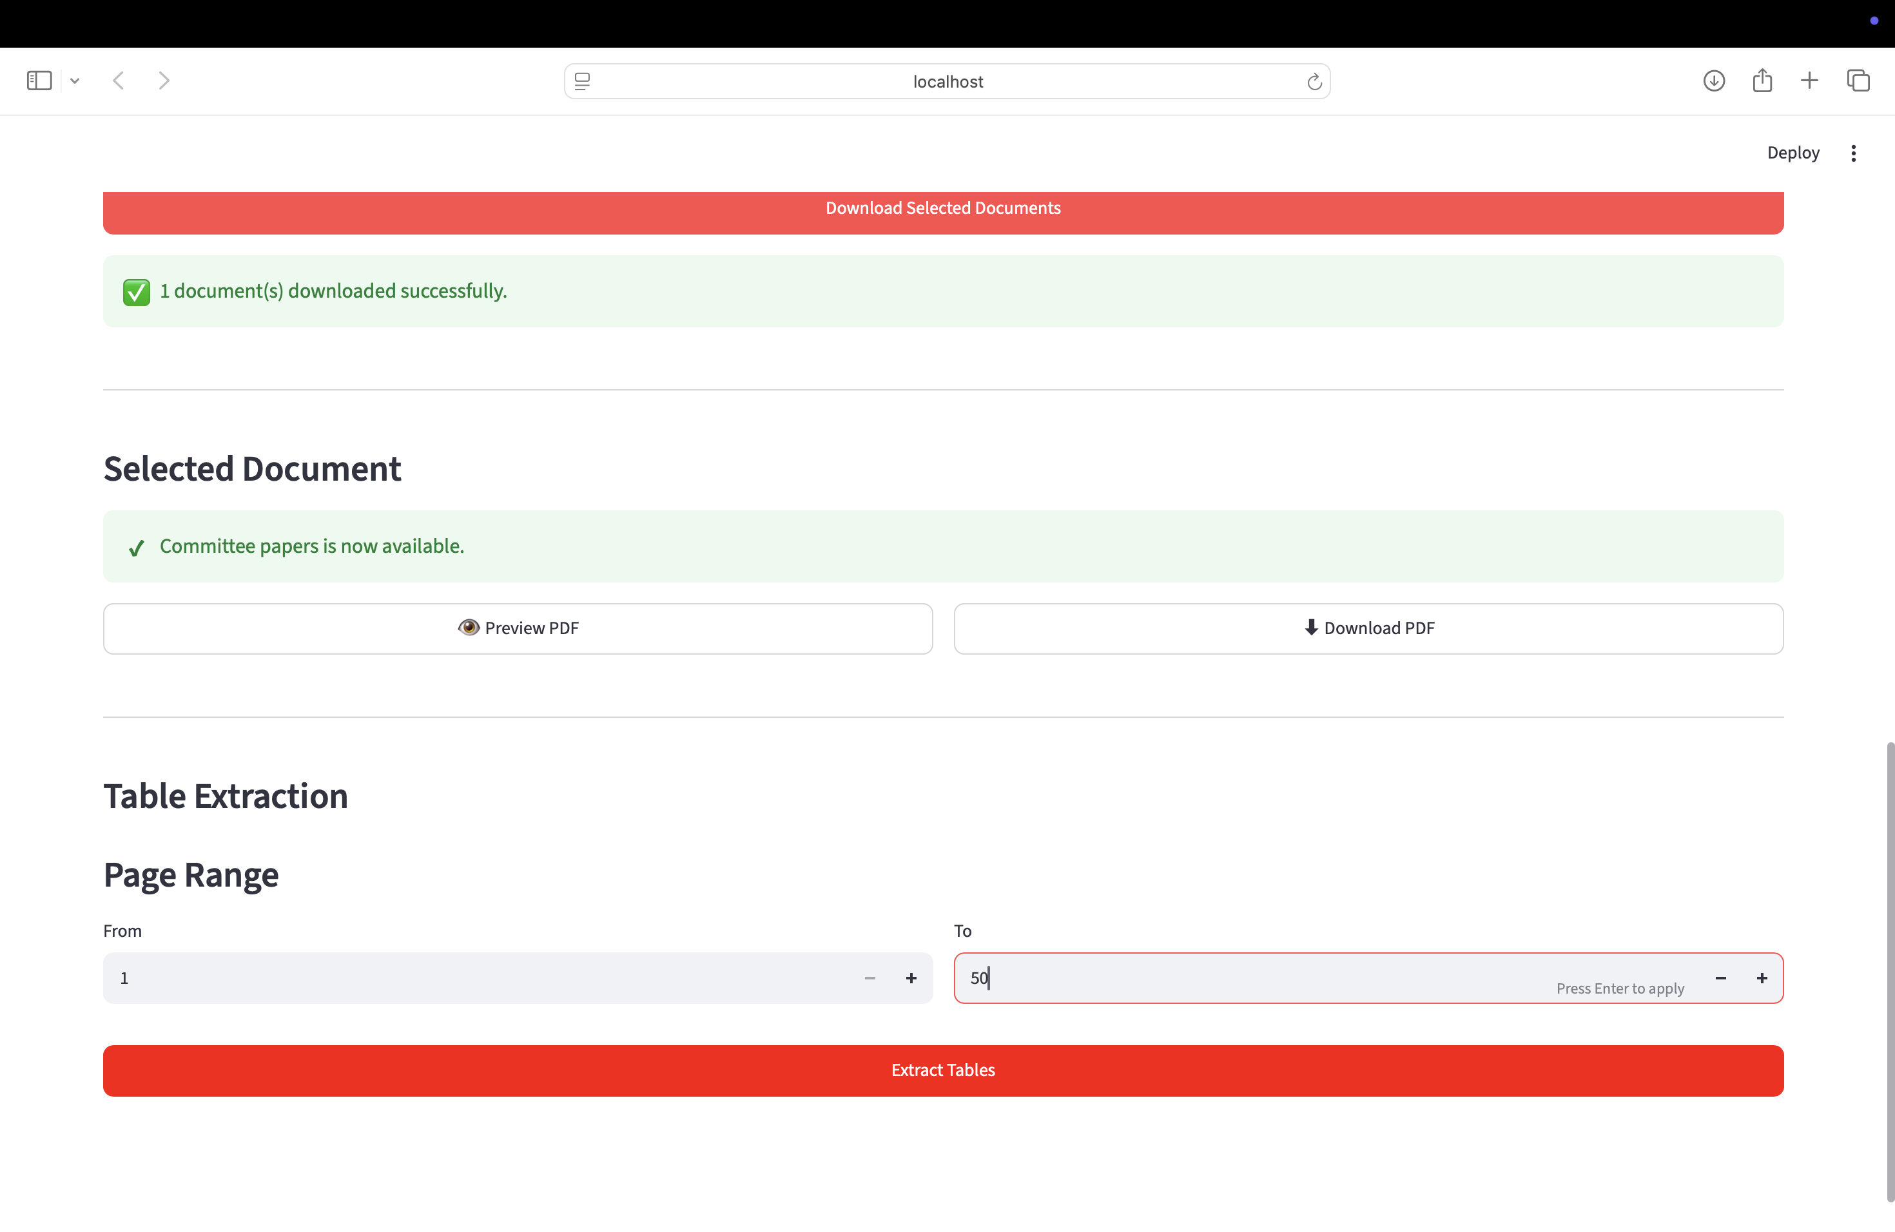
5. Extract tables.

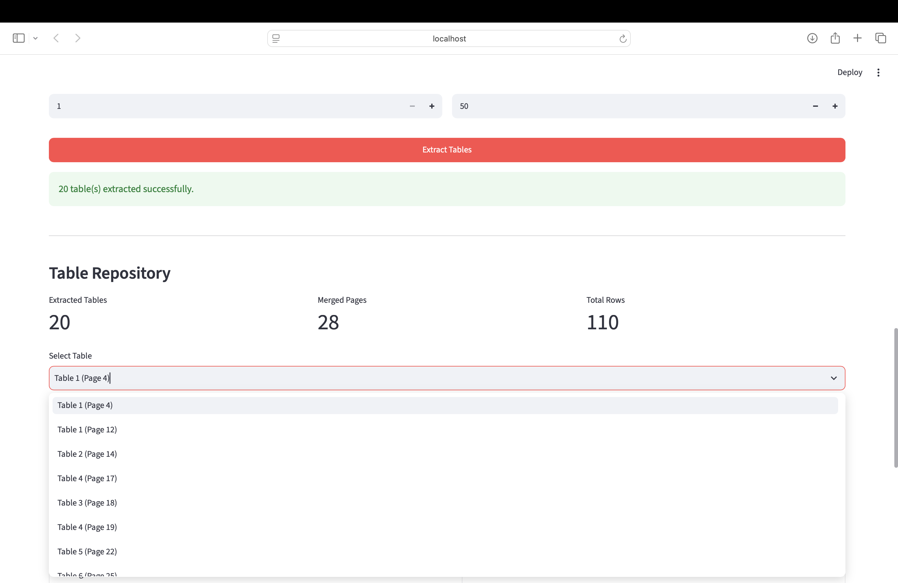

- Browse and export extracted tables. – click download excel for single table download and download all for all the tables download in one excel.

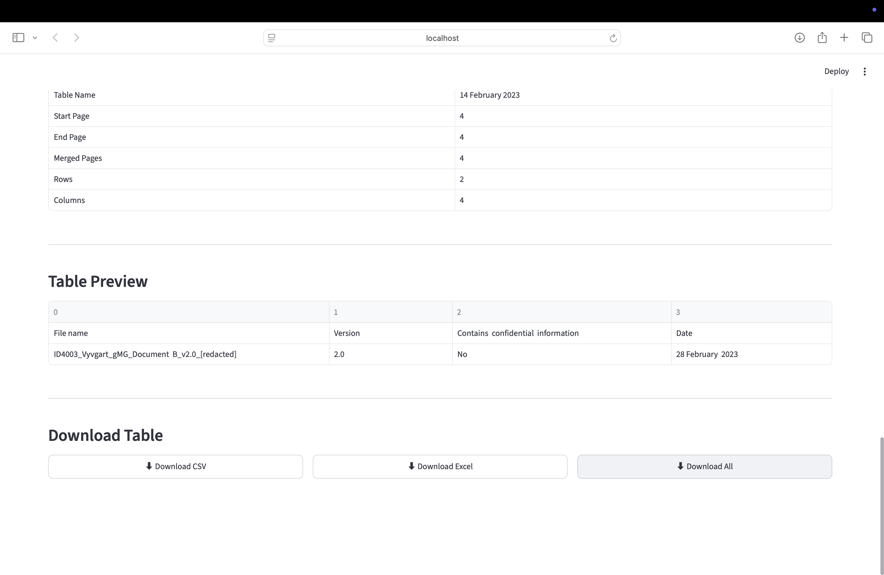

9. RAG Question Answering
The RAG module enables users to ask questions about downloaded NICE PDF documents. After selecting a document and page range, build the RAG pipeline and submit natural language questions. Answers are returned together with supporting evidence and performance metrics.
Typical workflow:
1. Select a TA.
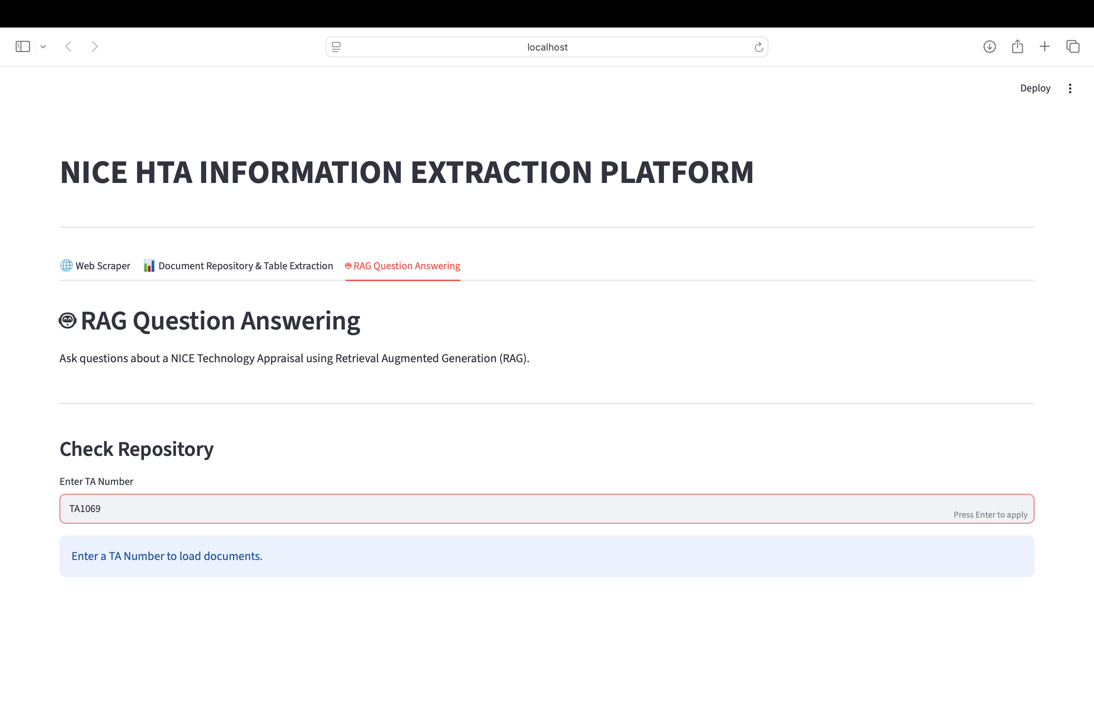
2. Choose a downloaded PDF.
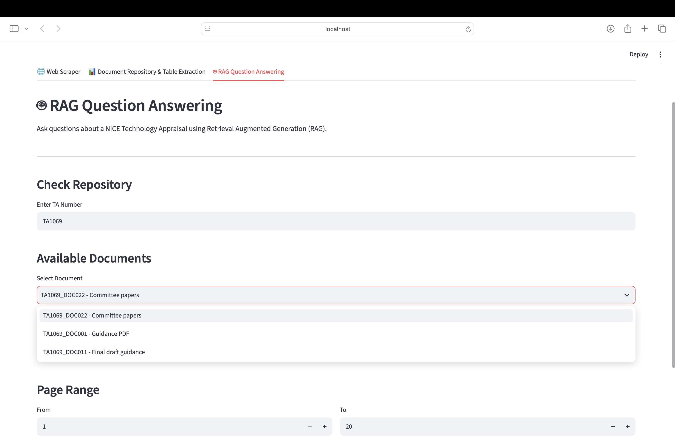

3. Build the RAG pipeline.

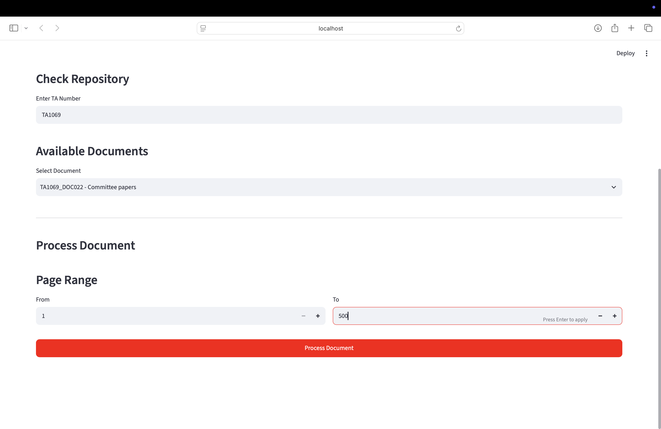
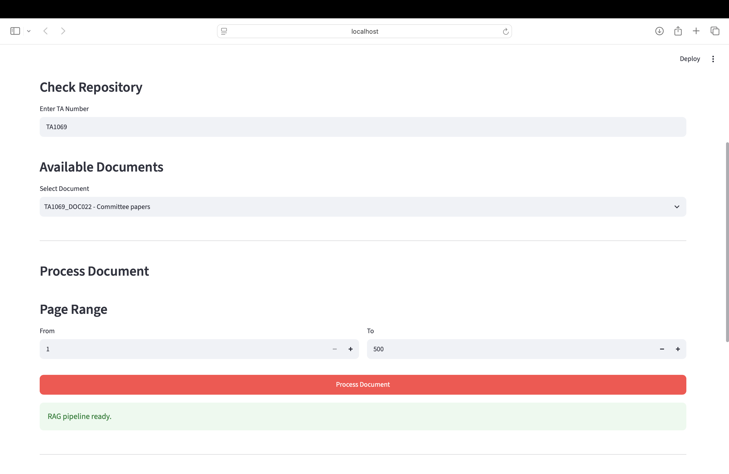

4. Ask questions.
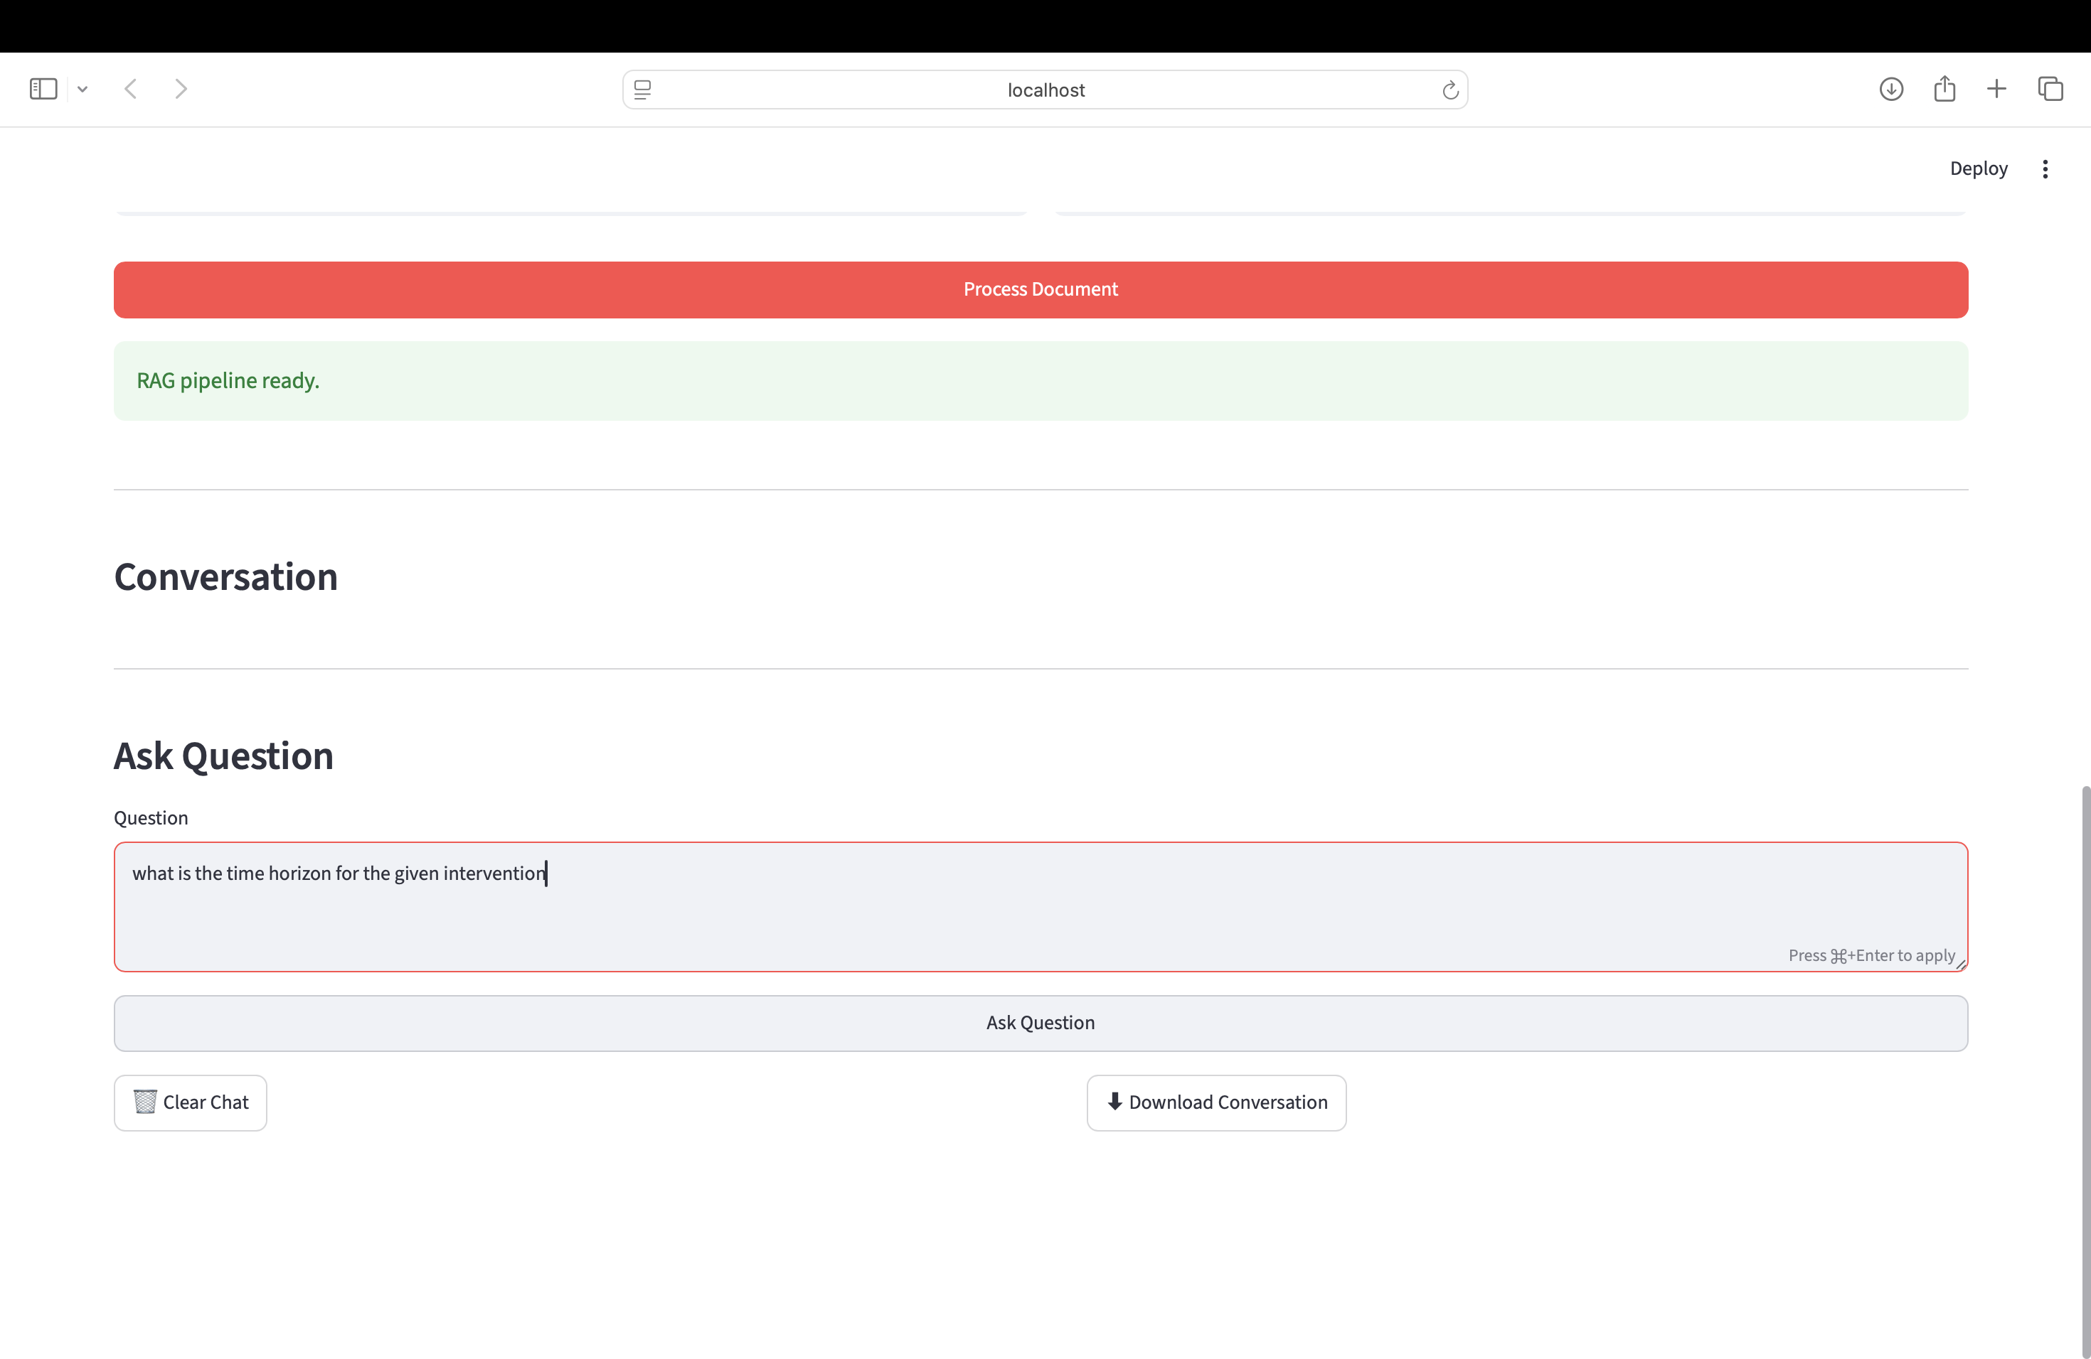

5. Review supporting evidence.
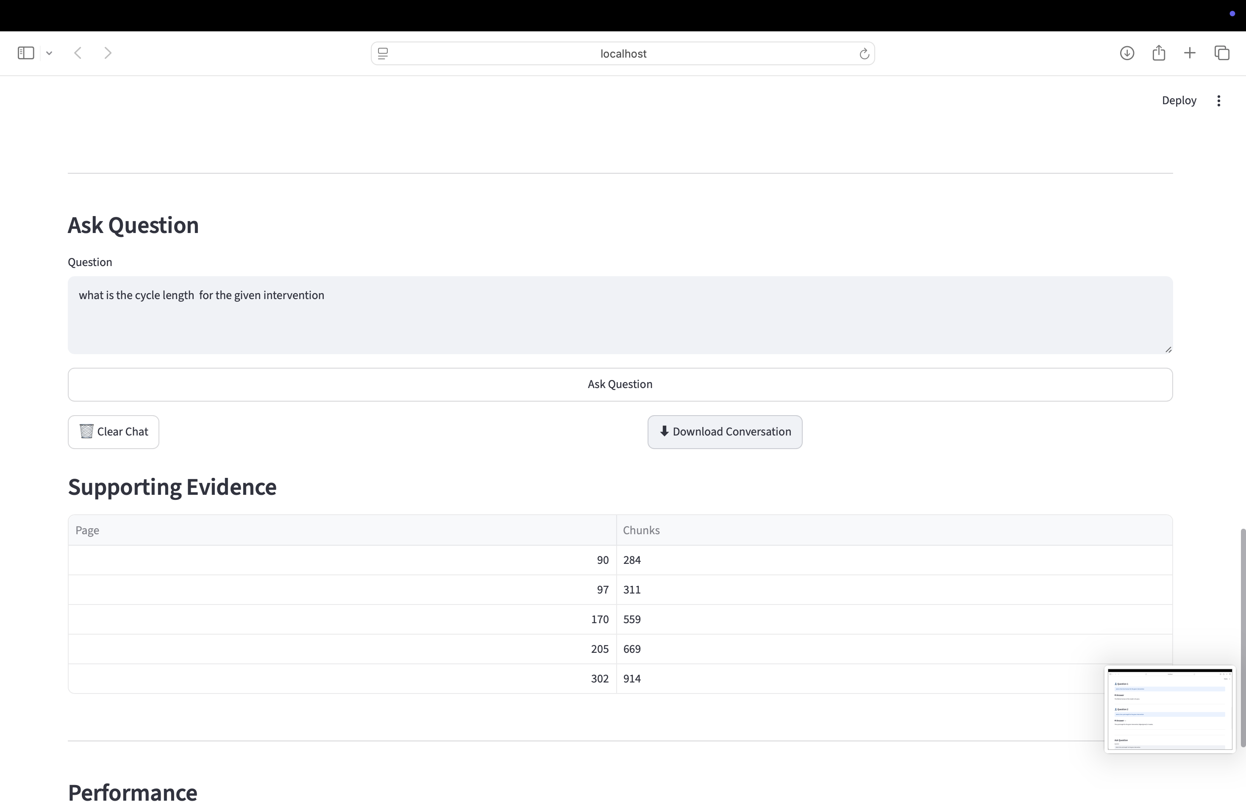
6. Download the conversation if required.
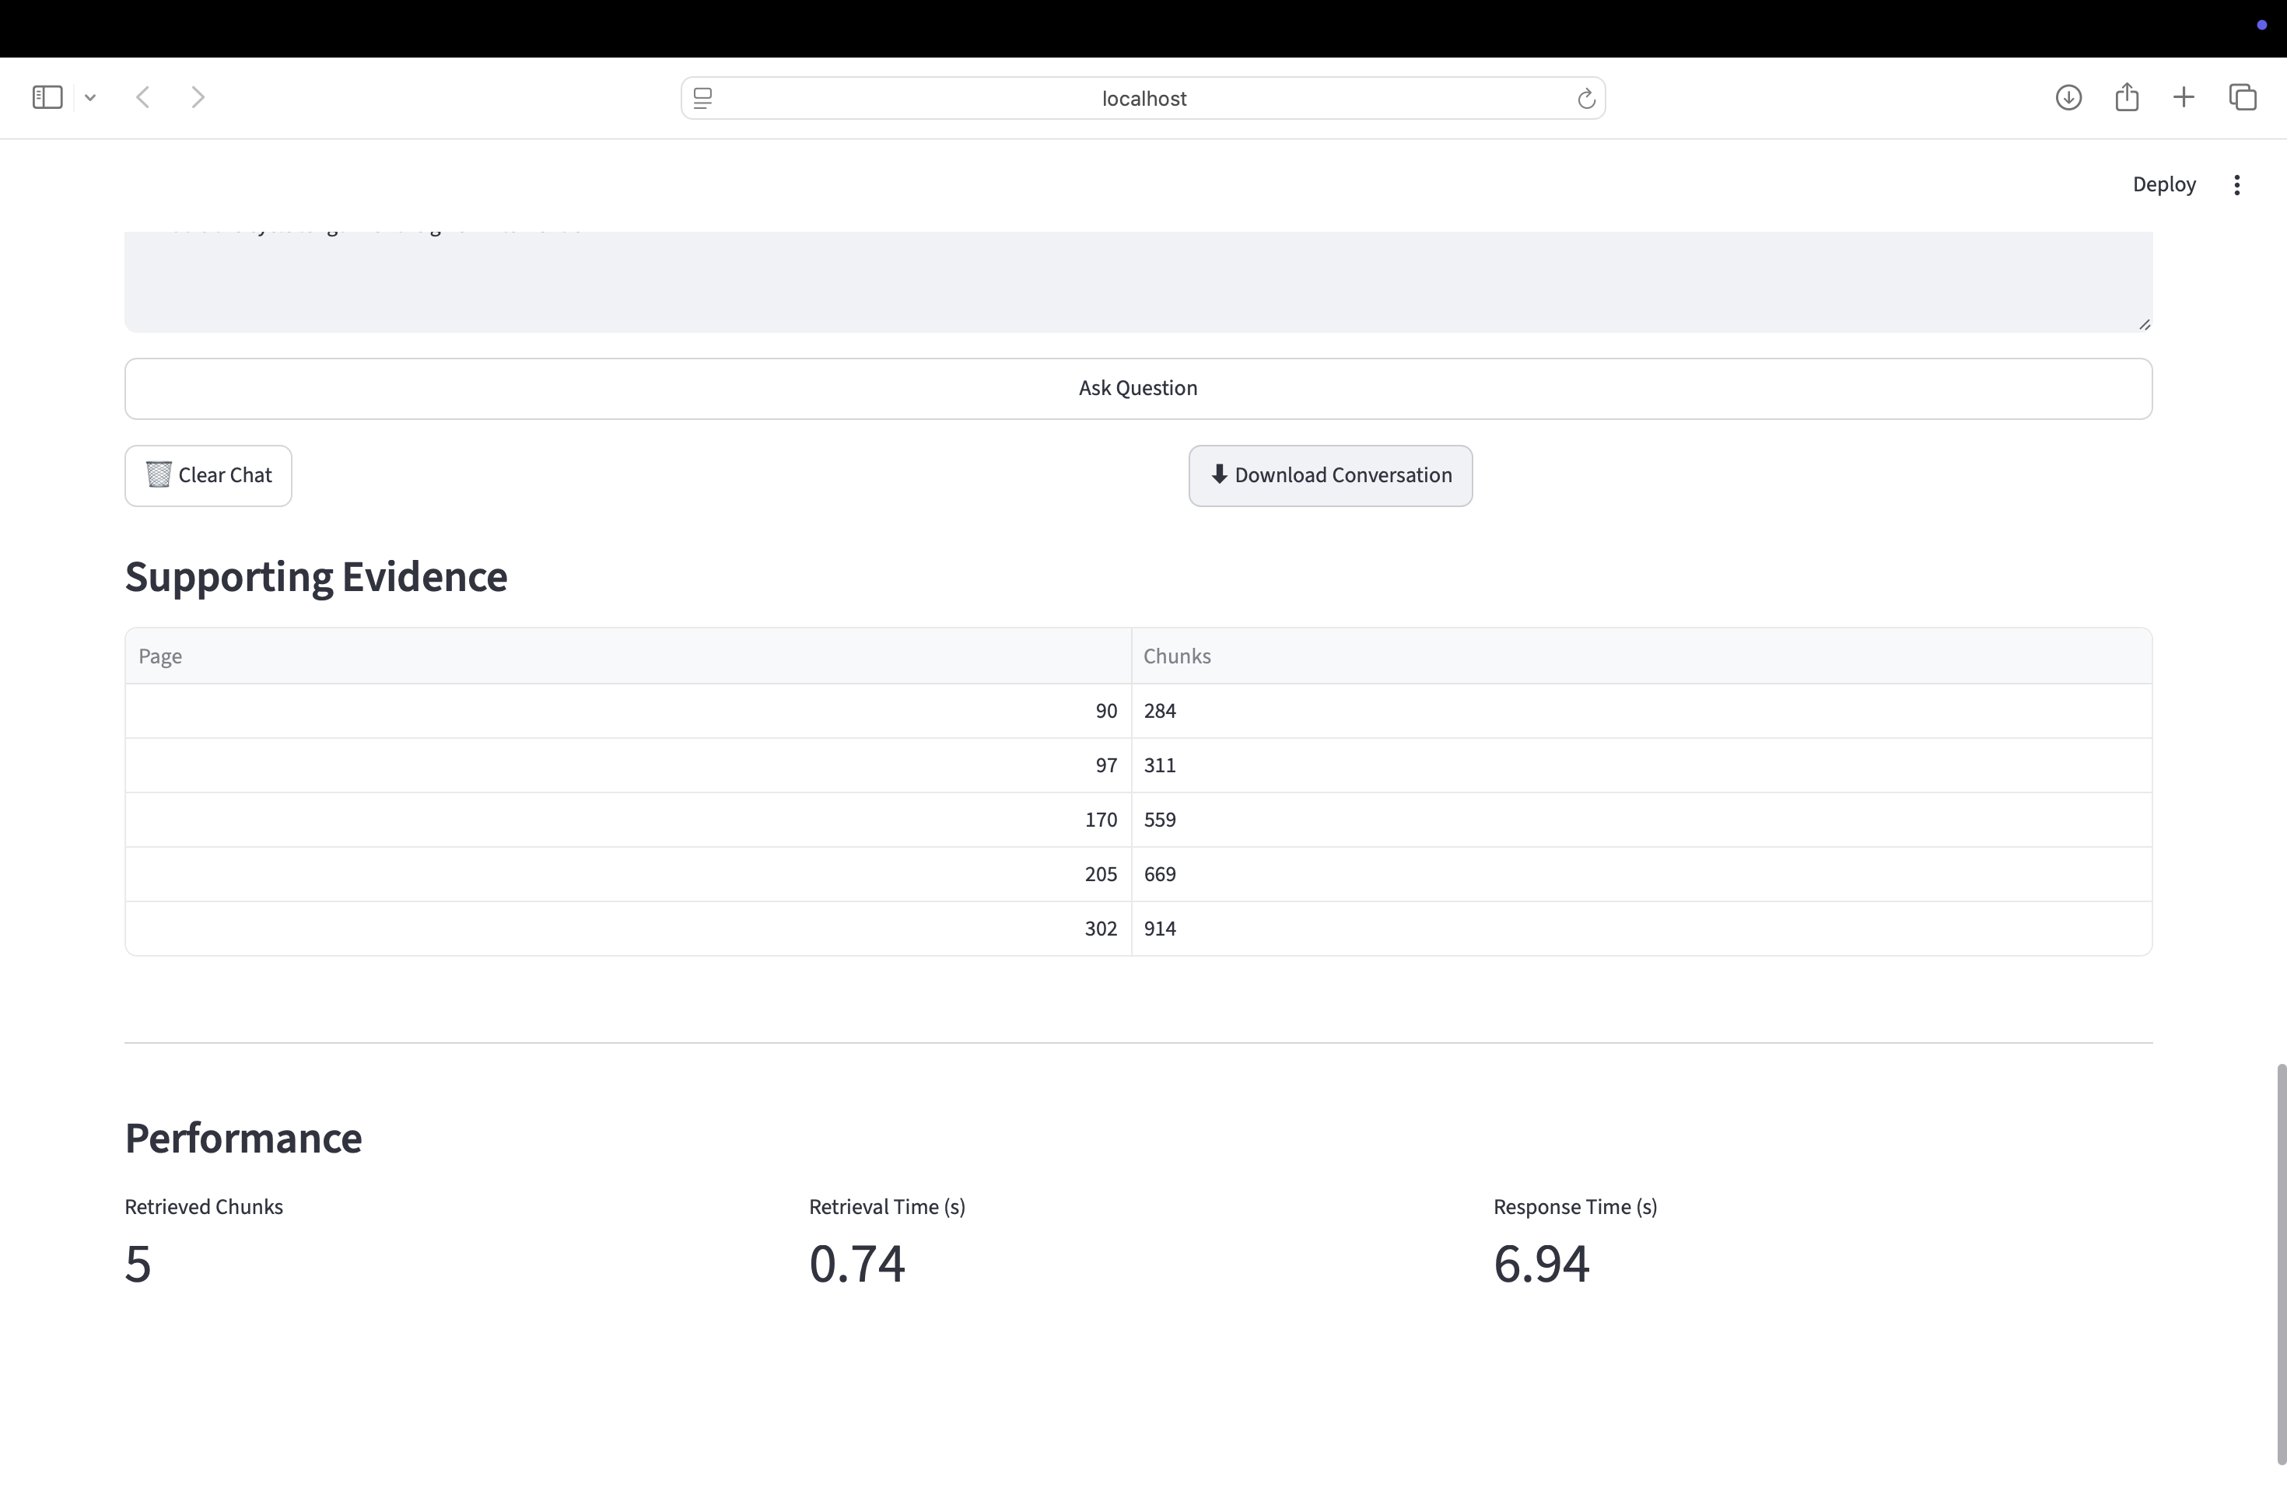

10. Troubleshooting and Best Practices
Common issues:
• Virtual environment not activated.
• Missing Python packages.
• Ollama not running.
• No downloaded PDF available.
• Invalid TA number or network connection.
Best practices:
• Keep dependencies updated.
• Verify supporting software before launching.
• Download documents before table extraction or RAG.
• Use appropriate page ranges for faster processing.
• Regularly back up repository data and exported outputs.

